08_Models

Jake Cavaiani

9/2/2022

The purpose of this script is to model HI/FI against fixed and random effects and perform model selection techniques to see which model is best fit

Input: Antecedent moisture conditions with HI_FI_BETA and catchment characteristics! Step 1) import full file Step 2) standardize and center the data Step 3) add fixed (storm total, intensity, week precip, month precip, 3month precip and doy) and random effects (catchments) Output: linear model plot

# Read in data #   
AMC <- read.csv("~/Documents/Storms_clean_repo/Output_from_analysis/07_Combine_HI_BETA_FI/antecedent_HI_FI_AllYears.csv")   
  
AMC <- AMC[,-c(1:2,14,15,17,27)] # cleaning up columns that are unnecessary   
  
colNames <- c("Hyst_index", "HI_ymin", "HI_ymax", "site.ID", "storm.ID", "month", "day", "response_var", "Flush_index", "FI_ymin", "FI_ymax", "year", "Parameter", "Beta_index", "SE", "CI", "Beta_ymin", "Beta_ymax", "t", "df", "p", "StormPrecip", "StormTemp", "PrecipWeek", "PrecipMonth", "ThreeMonth", "TempWeek", "Duration", "Intensity", "doy", "burn", "pf", "date", "TimeSinceChena")  
  
names(AMC)<- colNames # renaming columns   
  
  
##subsetting by solute   
# NO3 #  
HI_FI_NO3 = subset(AMC, response_var == "NO3")  
# fDOM #  
HI_FI_fDOM = subset(AMC, response_var == "fDOM")  
# SPC #  
HI_FI_SPC = subset(AMC, response_var == "SPC")  
# turb #  
HI_FI_turb = subset(AMC, response_var == "turb")

### Scaling and normalizing data

#### Scatter plot matrix

ADD IN R^2 value to see if you can get any sense of this!

NO3_data.1 <- HI_FI_NO3[,c("Hyst_index","StormPrecip")]  
  
pairs(NO3_data.1)

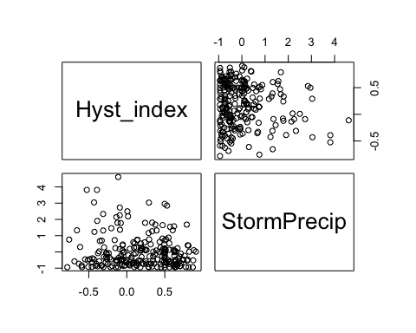

HI_FI_NO3 %>% ggplot(aes(x = StormPrecip, y = Hyst_index)) +   
 geom_hline(yintercept = 0, linetype = "dotted", size = 1) +  
 geom_errorbar(aes(ymin=HI_ymin, ymax=HI_ymax), colour="black", alpha=0.5, size=.5, width = 0.1)+   
 geom_point(aes(color = site.ID), size = 2) +  
 scale_color_manual(values = c("orange red", viridis::viridis(6)), "Catchment")+  
 geom_smooth(method = "lm", na.rm = TRUE, fullrange = TRUE, aes(group = 1)) +   
 stat_poly_eq(formula = y~x,  
 label.y = "top", label.x = "right",  
 aes(label = paste(..eq.label.., ..rr.label.., sep = "~~~")),   
 parse = TRUE) +   
 ylab("Hysteresis Index") +  
 ggtitle("HI vs. StormPrecip")

## `geom_smooth()` using formula 'y ~ x'

## Warning: Removed 2 rows containing non-finite values (stat_poly_eq).

## Warning: Removed 2 rows containing missing values (geom_point).

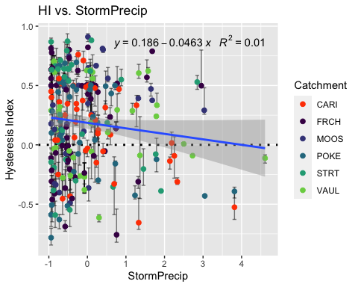

NO3_data.2 <- HI_FI_NO3[,c("Hyst_index","PrecipWeek")]  
  
pairs(NO3_data.2)

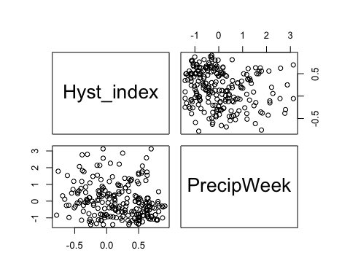

HI_FI_NO3 %>% ggplot(aes(x = PrecipWeek, y = Hyst_index)) +   
 geom_hline(yintercept = 0, linetype = "dotted", size = 1) +  
 geom_errorbar(aes(ymin=HI_ymin, ymax=HI_ymax), colour="black", alpha=0.5, size=.5, width = 0.1)+   
 geom_point(aes(color = site.ID), size = 2) +  
 scale_color_manual(values = c("#3288BD", "#FF7F00","#A6761D", "#6A3D9A", "#66C2A5", "#E7298A"), "Catchment")+  
 geom_smooth(method = "lm", na.rm = TRUE, fullrange = TRUE, aes(group = 1)) +   
 stat_poly_eq(formula = y~x,  
 label.y = "top", label.x = "right",  
 aes(label = paste(..eq.label.., ..rr.label.., sep = "~~~")),   
 parse = TRUE) +   
 ylab("Hysteresis Index") +  
 ggtitle("HI vs. PrecipWeek") +  
 theme_classic()

## `geom_smooth()` using formula 'y ~ x'

## Warning: Removed 2 rows containing non-finite values (stat_poly_eq).

## Warning: Removed 2 rows containing missing values (geom_point).

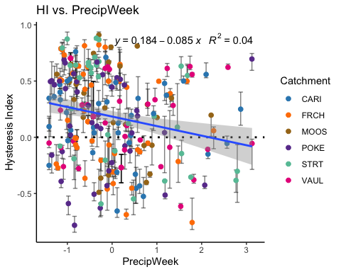

NO3_data.3 <- HI_FI_NO3[,c("Hyst_index","PrecipMonth")]  
  
pairs(NO3_data.3)

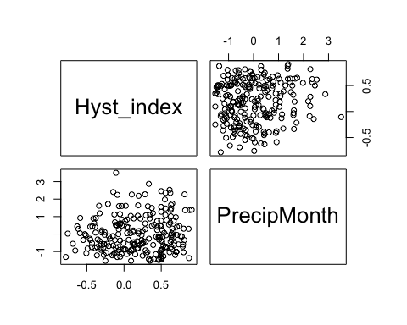

HI_FI_NO3 %>% ggplot(aes(x = PrecipMonth, y = Hyst_index)) +   
 geom_hline(yintercept = 0, linetype = "dotted", size = 1) +  
 geom_errorbar(aes(ymin=HI_ymin, ymax=HI_ymax), colour="black", alpha=0.5, size=.5, width = 0.1)+   
 geom_point(aes(color = site.ID), size = 2) +  
 scale_color_manual(values = c("orange red", viridis::viridis(6)), "Catchment")+  
 geom_smooth(method = "lm", na.rm = TRUE, fullrange = TRUE, aes(group = 1)) +   
 stat_poly_eq(formula = y~x,  
 label.y = "top", label.x = "right",  
 aes(label = paste(..eq.label.., ..rr.label.., sep = "~~~")),   
 parse = TRUE) +   
 ylab("Hysteresis Index") +  
 ggtitle("HI vs. PrecipMonth")

## `geom_smooth()` using formula 'y ~ x'

## Warning: Removed 2 rows containing non-finite values (stat_poly_eq).

## Warning: Removed 2 rows containing missing values (geom_point).

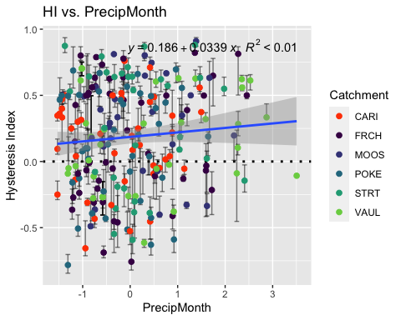

NO3_data.4 <- HI_FI_NO3[,c("Hyst_index","ThreeMonth")]  
  
pairs(NO3_data.4)

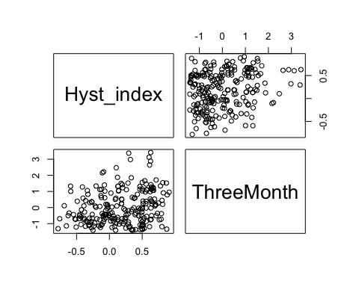

HI_FI_NO3 %>% ggplot(aes(x = ThreeMonth, y = Hyst_index)) +   
 geom_hline(yintercept = 0, linetype = "dotted", size = 1) +  
 geom_errorbar(aes(ymin=HI_ymin, ymax=HI_ymax), colour="black", alpha=0.5, size=.5, width = 0.1)+   
 geom_point(aes(color = site.ID), size = 2) +  
 scale_color_manual(values = c("orange red", viridis::viridis(6)), "Catchment")+  
 geom_smooth(method = "lm", na.rm = TRUE, fullrange = TRUE, aes(group = 1)) +   
 stat_poly_eq(formula = y~x,  
 label.y = "top", label.x = "right",  
 aes(label = paste(..eq.label.., ..rr.label.., sep = "~~~")),   
 parse = TRUE) +   
 ylab("Hysteresis Index") +  
 ggtitle("HI vs. ThreeMonth")

## `geom_smooth()` using formula 'y ~ x'

## Warning: Removed 2 rows containing non-finite values (stat_poly_eq).

## Warning: Removed 2 rows containing missing values (geom_point).

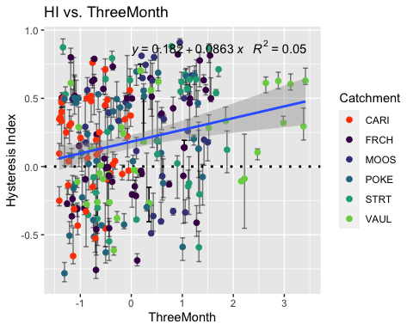

NO3_data.5 <- HI_FI_NO3[,c("Hyst_index","Intensity")]  
  
pairs(NO3_data.5)

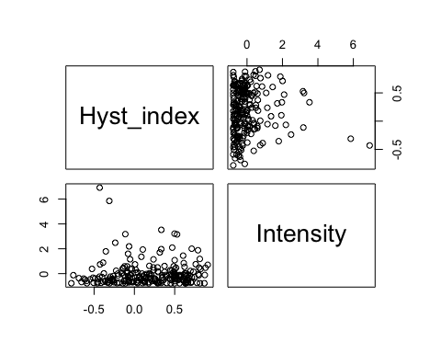

HI_FI_NO3 %>% ggplot(aes(x = Intensity, y = Hyst_index)) +   
 geom_hline(yintercept = 0, linetype = "dotted", size = 1) +  
 geom_errorbar(aes(ymin=HI_ymin, ymax=HI_ymax), colour="black", alpha=0.5, size=.5, width = 0.1)+   
 geom_point(aes(color = site.ID), size = 2) +  
 scale_color_manual(values = c("orange red", viridis::viridis(6)), "Catchment")+  
 ylab("Hysteresis Index") +  
 ggtitle("HI vs. Intensity")

## Warning: Removed 8 rows containing missing values (geom_point).

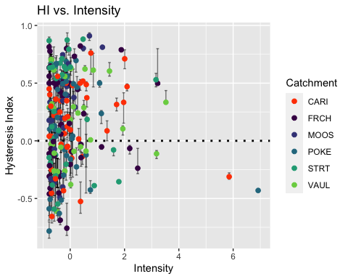

NO3_data.6 <- HI_FI_NO3[,c("Hyst_index","StormTemp")]  
  
pairs(NO3_data.6)

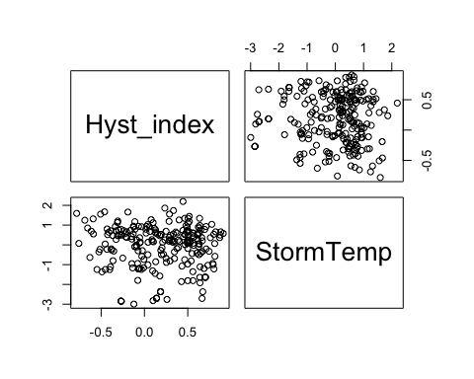

HI_FI_NO3 %>% ggplot(aes(x = StormTemp, y = Hyst_index)) +   
 geom_hline(yintercept = 0, linetype = "dotted", size = 1) +  
 geom_errorbar(aes(ymin=HI_ymin, ymax=HI_ymax), colour="black", alpha=0.5, size=.5, width = 0.1)+   
 geom_point(aes(color = site.ID), size = 2) +  
 scale_color_manual(values = c("orange red", viridis::viridis(6)), "Catchment")+  
 geom_smooth(method = "lm", na.rm = TRUE, fullrange = TRUE, aes(group = 1)) +   
 stat_poly_eq(formula = y~x,  
 label.y = "top", label.x = "right",  
 aes(label = paste(..eq.label.., ..rr.label.., sep = "~~~")),   
 parse = TRUE) +   
 ylab("Hysteresis Index") +  
 ggtitle("HI vs. StormTemp")

## `geom_smooth()` using formula 'y ~ x'

## Warning: Removed 7 rows containing non-finite values (stat_poly_eq).

## Warning: Removed 7 rows containing missing values (geom_point).

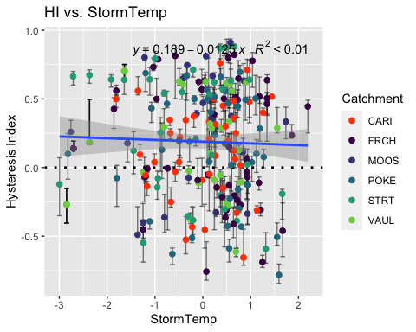

NO3_data.7 <- HI_FI_NO3[,c("Hyst_index","TempWeek")]  
  
pairs(NO3_data.7)

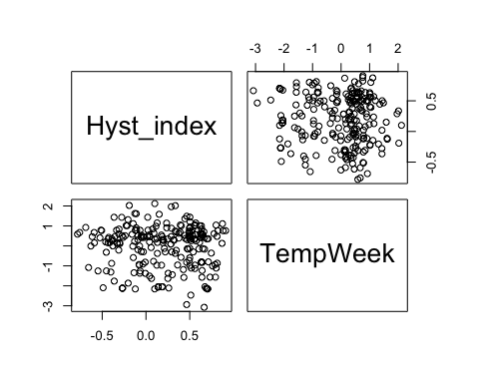

HI_FI_NO3 %>% ggplot(aes(x = TempWeek, y = Hyst_index)) +   
 geom_hline(yintercept = 0, linetype = "dotted", size = 1) +  
 geom_errorbar(aes(ymin=HI_ymin, ymax=HI_ymax), colour="black", alpha=0.5, size=.5, width = 0.1)+   
 geom_point(aes(color = site.ID), size = 2) +  
 scale_color_manual(values = c("orange red", viridis::viridis(6)), "Catchment")+  
 geom_smooth(method = "lm", na.rm = TRUE, fullrange = TRUE, aes(group = 1)) +   
 stat_poly_eq(formula = y~x,  
 label.y = "top", label.x = "right",  
 aes(label = paste(..eq.label.., ..rr.label.., sep = "~~~")),   
 parse = TRUE) +   
 ylab("Hysteresis Index") +  
 ggtitle("HI vs. StormTemp")

## `geom_smooth()` using formula 'y ~ x'

## Warning: Removed 10 rows containing non-finite values (stat_poly_eq).

## Warning: Removed 10 rows containing missing values (geom_point).

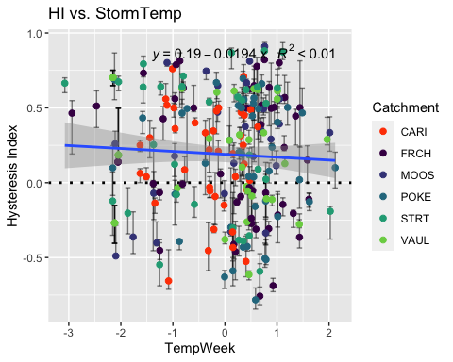

NO3_data.8 <- HI_FI_NO3[,c("Hyst_index","TimeSinceChena")]  
  
pairs(NO3_data.8)

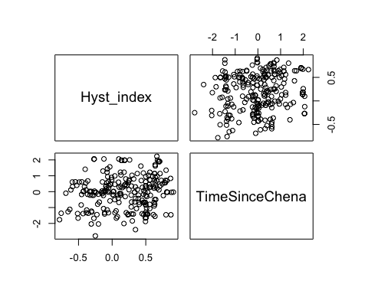

HI_FI_NO3 %>% ggplot(aes(x = TimeSinceChena, y = Hyst_index)) +   
 geom_hline(yintercept = 0, linetype = "dotted", size = 1) +  
 geom_errorbar(aes(ymin=HI_ymin, ymax=HI_ymax), colour="black", alpha = 0.5, size=.5, width = 0.1)+   
 geom_point(aes(color = site.ID, shape = as.factor(year)), size = 2) +  
 scale_color_manual(values = c("orange red", viridis::viridis(6)), "Catchment")+  
 geom_smooth(method = "lm", na.rm = TRUE, fullrange = TRUE, aes(group = 1)) +   
 stat_poly_eq(formula = y~x,  
 label.y = "top", label.x = "right",  
 aes(label = paste(..eq.label.., ..rr.label.., sep = "~~~")),   
 parse = TRUE) +   
 ylab("Hysteresis Index") +  
 ggtitle("HI vs. StormTemp")

## `geom_smooth()` using formula 'y ~ x'

## Warning: Removed 2 rows containing non-finite values (stat_poly_eq).

## Warning: Removed 2 rows containing missing values (geom_point).

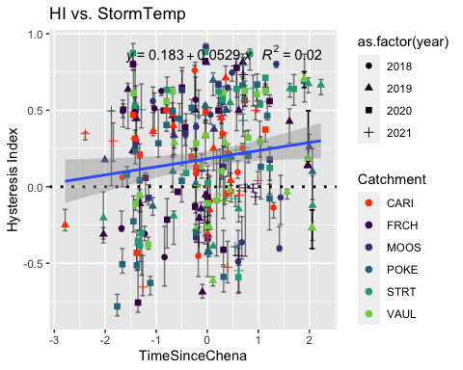

#### Correlation

NO3_data <- HI_FI_NO3[,c("Hyst_index", "site.ID", "StormPrecip", "PrecipWeek", "PrecipMonth", "ThreeMonth", "Intensity", "TimeSinceChena", "pf", "burn", "year")]  
NO3_data <- na.omit(NO3_data) # 244 to 236 rows   
  
NO3_data <- NO3_data[, c(1,3,4,5,6,7,8,2,9,10,11)]  
cor(NO3_data[,c(1:7)])

## Hyst_index StormPrecip PrecipWeek PrecipMonth ThreeMonth  
## Hyst_index 1.000000000 -0.10271089 -0.218476823 0.08274460 0.2197586  
## StormPrecip -0.102710887 1.00000000 0.081835471 -0.08736168 -0.1498579  
## PrecipWeek -0.218476823 0.08183547 1.000000000 0.57501225 0.1930355  
## PrecipMonth 0.082744602 -0.08736168 0.575012253 1.00000000 0.5881621  
## ThreeMonth 0.219758637 -0.14985787 0.193035454 0.58816213 1.0000000  
## Intensity 0.009522613 0.64643143 -0.009912431 -0.08693366 -0.1669423  
## TimeSinceChena 0.150047850 -0.08794612 -0.107777987 0.04131833 0.5434792  
## Intensity TimeSinceChena  
## Hyst_index 0.009522613 0.15004785  
## StormPrecip 0.646431431 -0.08794612  
## PrecipWeek -0.009912431 -0.10777799  
## PrecipMonth -0.086933659 0.04131833  
## ThreeMonth -0.166942344 0.54347918  
## Intensity 1.000000000 -0.10190320  
## TimeSinceChena -0.101903198 1.00000000

ggpairs(NO3_data,  
 columns = 1:7,  
 ggplot2::aes(colour = site.ID))

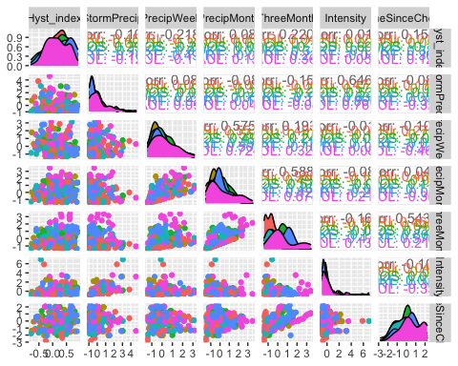

ggsave("pairs1.pdf",  
 width = 10, height = 10)

1. StormTemp is heavily correlated with TempWeek leading up to a storm (0.778) but TempWeek is slightly more correlated with HI (-.05 to -.03)
2. StormTemp is also correlated with time since chena (-0.735) but time since chena is more correlated with HI (0.251 vs. -0.173) so this makes me want to keep Time since Chena and temperature a week before considering that is a more marginal comparison with HI and the temperature predictors.

3)Precip week is correlated with precip month (0.511) but precip week is more correlated with HI than precip month (-0.242 vs. 0.048)

4)Precip month is correlated with three month precip (0.591) but three month precip is more correlated with HI (0.220 vs. 0.048)

1. Three month is correlated with Time since Chena (0.619) but time since chena is more correlated with HI (0.251 vs. 0.220)

* to sum up this makes me want to drop storm temperature and three month precipitation…..but lets run the model with all of the candidate predictors first and go from there

HI_FI_NO3_MOOS <- subset(HI_FI_NO3, site.ID == "MOOS")  
HI_FI_NO3_FRCH <- subset(HI_FI_NO3, site.ID == "FRCH")  
HI_FI_NO3_CARI <- subset(HI_FI_NO3, site.ID == "CARI")  
HI_FI_NO3_POKE <- subset(HI_FI_NO3, site.ID == "POKE")  
HI_FI_NO3_VAUL <- subset(HI_FI_NO3, site.ID == "VAUL")  
HI_FI_NO3_STRT <- subset(HI_FI_NO3, site.ID == "STRT")  
  
MOOS.model <- lm(Hyst_index ~ StormPrecip + PrecipWeek + PrecipMonth + TimeSinceChena, data = HI_FI_NO3_MOOS)  
  
FRCH.model <- lm(Hyst_index ~ StormPrecip + PrecipWeek + PrecipMonth + TimeSinceChena, data = HI_FI_NO3_FRCH)  
  
CARI.model <- lm(Hyst_index ~ StormPrecip + PrecipWeek + PrecipMonth + TimeSinceChena, data = HI_FI_NO3_CARI)  
  
POKE.model <- lm(Hyst_index ~ StormPrecip + PrecipWeek + PrecipMonth + TimeSinceChena, data = HI_FI_NO3_POKE)  
  
VAUL.model <- lm(Hyst_index ~ StormPrecip + PrecipWeek + PrecipMonth + TimeSinceChena, data = HI_FI_NO3_VAUL)  
  
STRT.model <- lm(Hyst_index ~ StormPrecip + PrecipWeek + PrecipMonth + TimeSinceChena, data = HI_FI_NO3_STRT)  
  
Plot_1 <- plot_summs(MOOS.model, FRCH.model,   
 CARI.model, POKE.model,   
 VAUL.model, STRT.model, scale = TRUE,  
 model.names = c("MOOS", "FRCH", "CARI", "POKE", "VAUL", "STRT"),  
 colors = c("#A6761D", "#FF7F00","#3288BD", "#6A3D9A", "#E7298A", "#66C2A5"))

## Loading required namespace: broom.mixed  
## Loading required namespace: broom.mixed  
## Loading required namespace: broom.mixed  
## Loading required namespace: broom.mixed  
## Loading required namespace: broom.mixed  
## Loading required namespace: broom.mixed

Plot_1 +   
 xlab("Coefficient estimate") + ylab("") +  
 geom_vline(xintercept = 0,  
 colour = "grey80",  
 linetype = 1) +  
scale_y_discrete(labels= c("Seasonality",   
 "Precipitation Month",   
 "Precipitation Week",  
 "Storm Precipitation")) +  
 theme_bw()

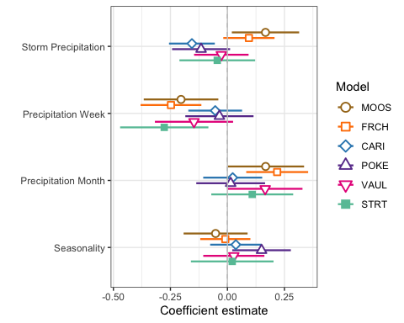

ggsave(path = "~/Documents/Storms_clean_repo/plots/Coefficient_Plots/HI",   
 filename = "HI_NO3.pdf",  
 width = 7, height = 7)

M1 <- lmer(Hyst_index ~ StormPrecip + PrecipWeek + PrecipMonth + TimeSinceChena + (1|site.ID), data = HI_FI_NO3)

## boundary (singular) fit: see ?isSingular

pr <- ggpredict(M1)  
  
plot(pr, add.data = TRUE)

## $StormPrecip

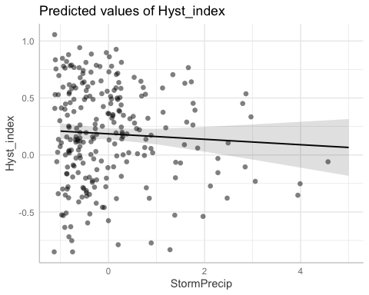

##   
## $PrecipWeek

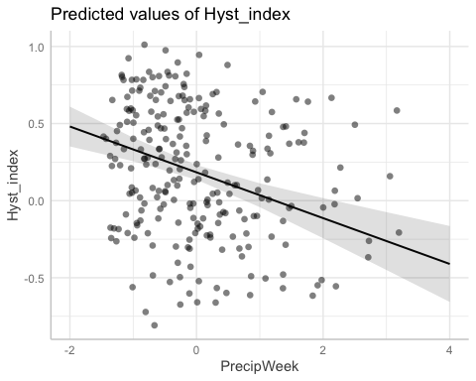

##   
## $PrecipMonth

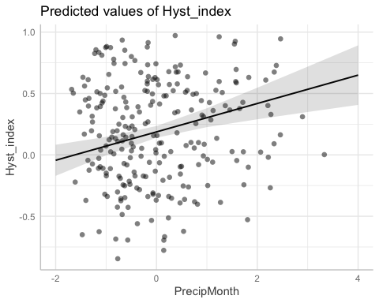

##   
## $TimeSinceChena

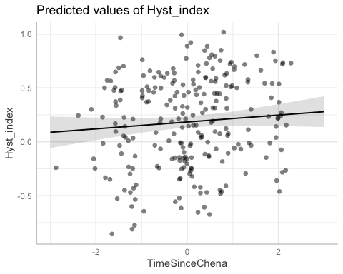

pr <- ggpredict(MOOS.model)  
plot(pr, add.data = TRUE)

## $StormPrecip

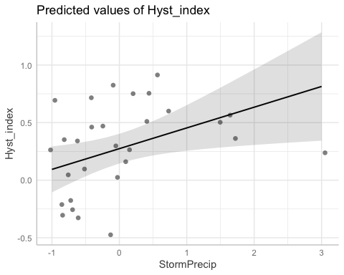

##   
## $PrecipWeek

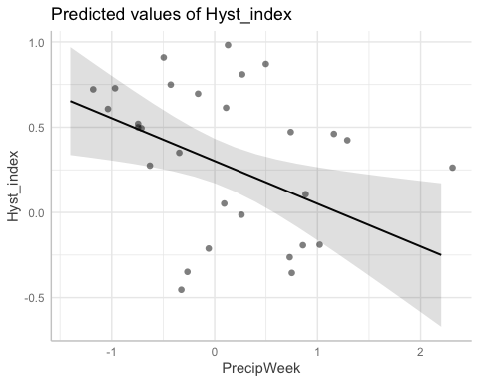

##   
## $PrecipMonth

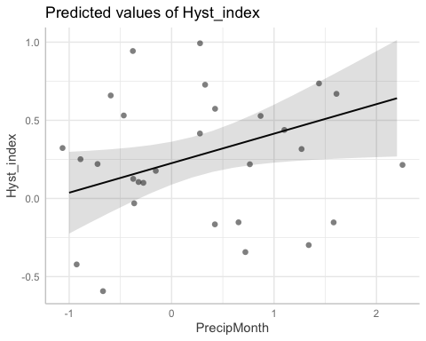

##   
## $TimeSinceChena

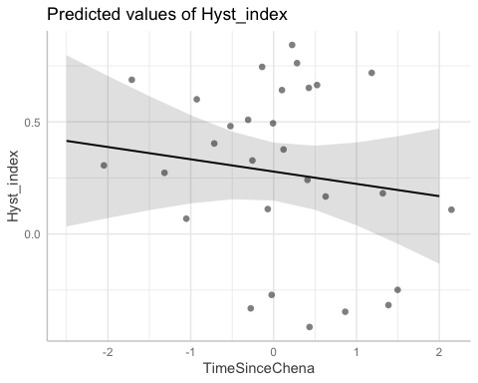

# partial residual plot test to get each site by color   
mo <- ggpredict(MOOS.model)  
plot(mo, add.data = TRUE)

## $StormPrecip

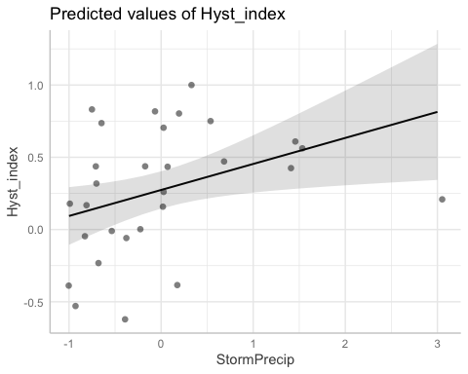

##   
## $PrecipWeek

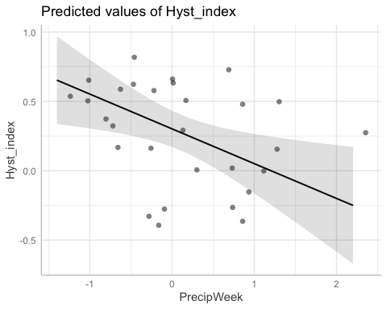

##   
## $PrecipMonth

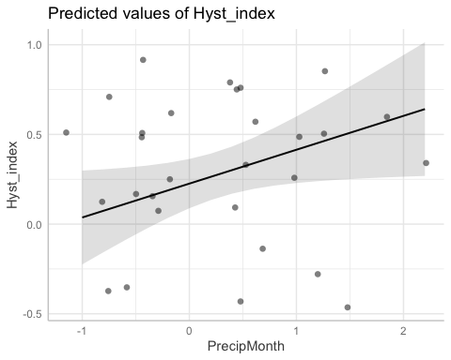

##   
## $TimeSinceChena

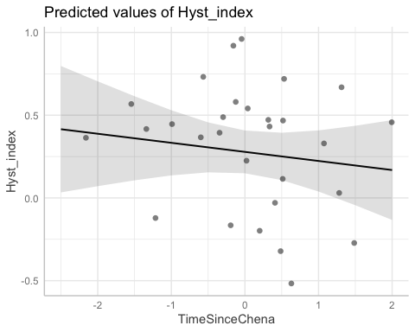

fr <- ggpredict(FRCH.model)  
plot(fr, add.data = TRUE)

## $StormPrecip

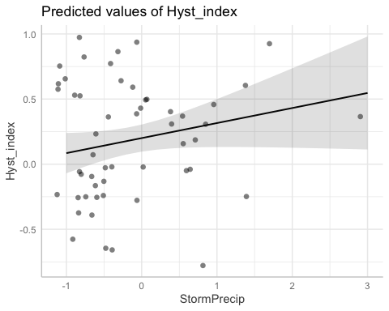

##   
## $PrecipWeek

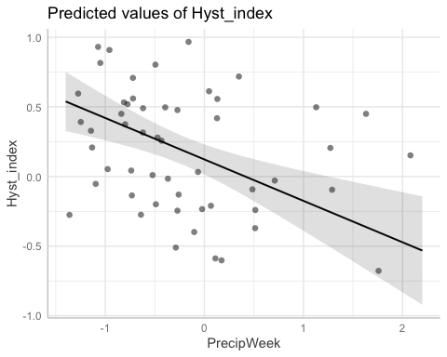

##   
## $PrecipMonth

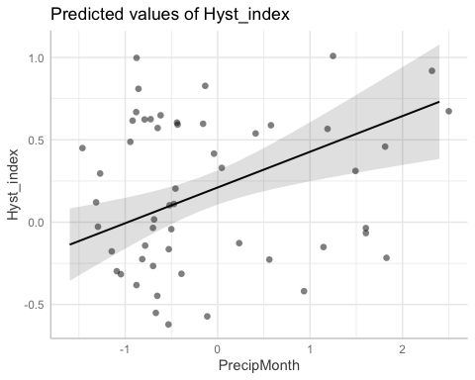

##   
## $TimeSinceChena

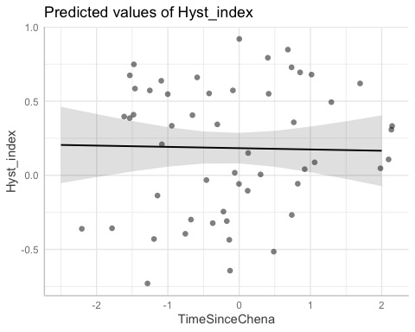

ca <- ggpredict(CARI.model)  
plot(ca, add.data = TRUE)

## $StormPrecip

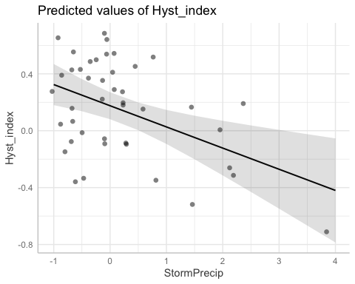

##   
## $PrecipWeek

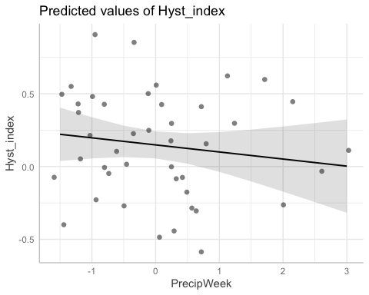

##   
## $PrecipMonth

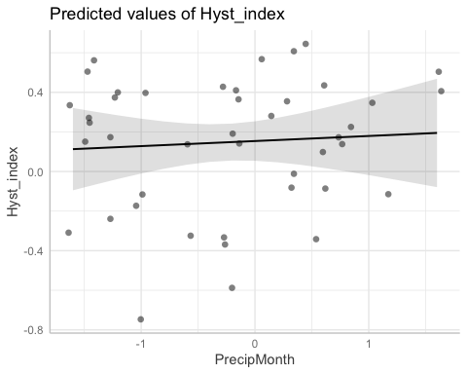

##   
## $TimeSinceChena

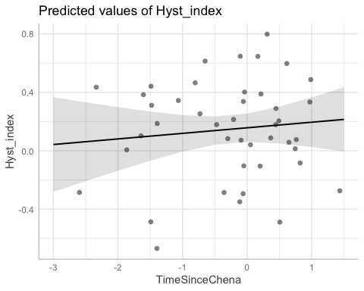

po <- ggpredict(POKE.model)  
plot(po, add.data = TRUE)

## $StormPrecip

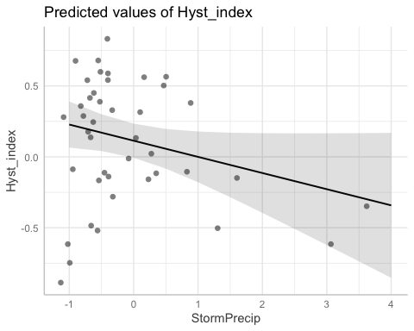

##   
## $PrecipWeek

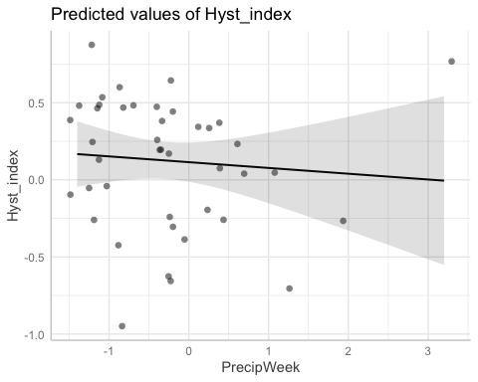

##   
## $PrecipMonth

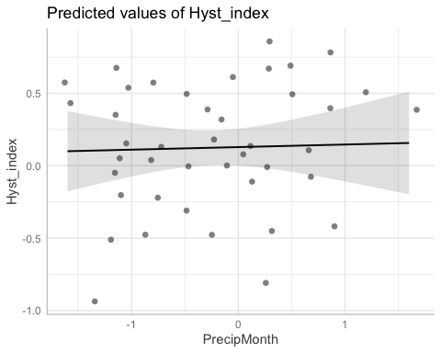

##   
## $TimeSinceChena

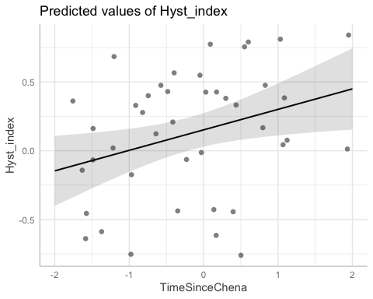

va <- ggpredict(VAUL.model)  
plot(va, add.data = TRUE)

## $StormPrecip

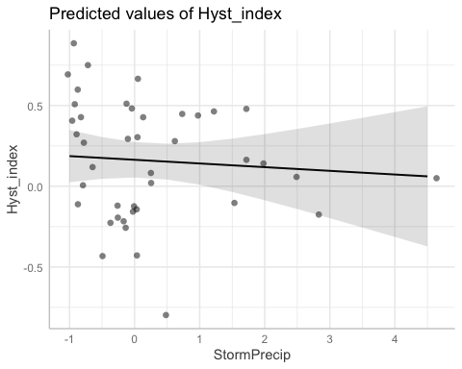

##   
## $PrecipWeek

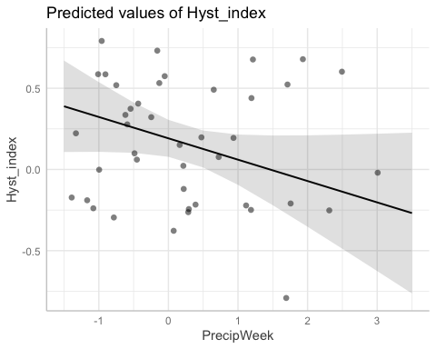

##   
## $PrecipMonth

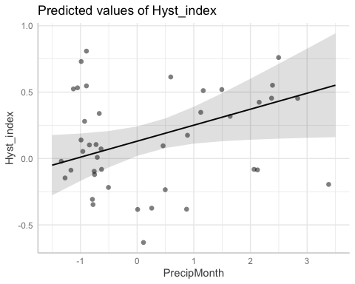

##   
## $TimeSinceChena

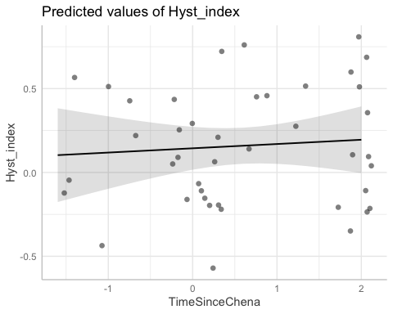

st <- ggpredict(STRT.model)  
plot(st, add.data = TRUE)

## $StormPrecip

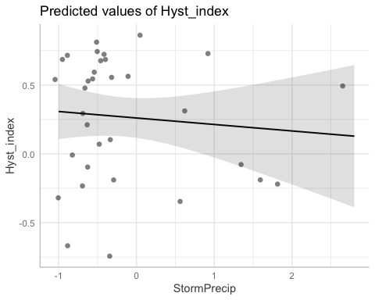

##   
## $PrecipWeek

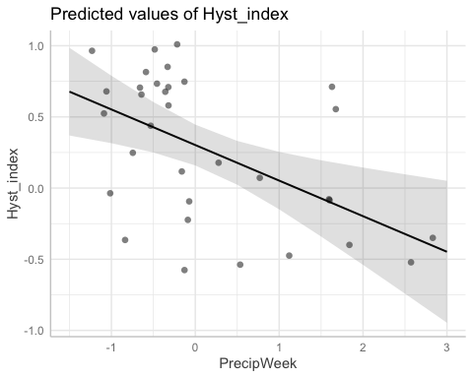

##   
## $PrecipMonth

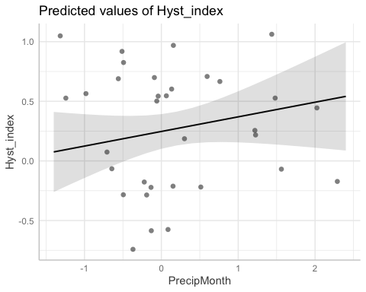

##   
## $TimeSinceChena

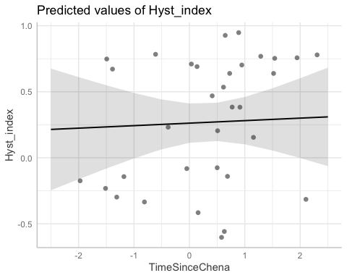

# diagnostic plots

summary(M1)

## Linear mixed model fit by REML ['lmerMod']  
## Formula:   
## Hyst_index ~ StormPrecip + PrecipWeek + PrecipMonth + TimeSinceChena +   
## (1 | site.ID)  
## Data: HI_FI_NO3  
##   
## REML criterion at convergence: 240  
##   
## Scaled residuals:   
## Min 1Q Median 3Q Max   
## -2.79046 -0.79598 0.04302 0.78775 2.25129   
##   
## Random effects:  
## Groups Name Variance Std.Dev.  
## site.ID (Intercept) 0.0000 0.0000   
## Residual 0.1437 0.3791   
## Number of obs: 242, groups: site.ID, 6  
##   
## Fixed effects:  
## Estimate Std. Error t value  
## (Intercept) 0.18453 0.02439 7.565  
## StormPrecip -0.02388 0.02497 -0.956  
## PrecipWeek -0.14855 0.03074 -4.833  
## PrecipMonth 0.11563 0.03019 3.830  
## TimeSinceChena 0.03188 0.02320 1.374  
##   
## Correlation of Fixed Effects:  
## (Intr) StrmPr PrcpWk PrcpMn  
## StormPrecip -0.007   
## PrecipWeek -0.004 -0.130   
## PrecipMonth 0.017 0.149 -0.600   
## TimeSincChn -0.038 0.052 0.152 -0.120  
## optimizer (nloptwrap) convergence code: 0 (OK)  
## boundary (singular) fit: see ?isSingular

plot(M1, type=c("p","smooth"), col.line=1)

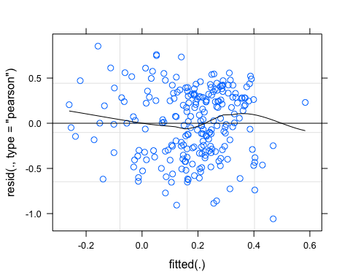

lattice::qqmath(M1)

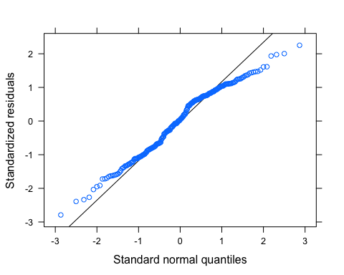

plot(M1, rstudent(.) ~ hatvalues(.))

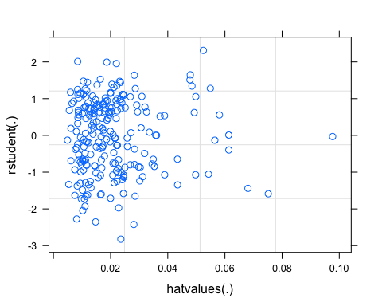

#fDOM #

### fDOM ###   
#### Correlation   
fDOM_data <- HI_FI_fDOM[,c("Hyst_index", "site.ID", "StormPrecip", "PrecipWeek", "PrecipMonth", "ThreeMonth", "Intensity", "TimeSinceChena", "pf", "burn", "year")]  
fDOM_data <- na.omit(fDOM_data) # 255 to 253 rows   
  
fDOM_data <- fDOM_data[, c(1,3,4,5,6,7,8,2,9,10,11)]  
cor(fDOM_data[,c(1:7)])

## Hyst_index StormPrecip PrecipWeek PrecipMonth ThreeMonth  
## Hyst_index 1.00000000 0.04368045 0.15589475 0.14021372 0.03056870  
## StormPrecip 0.04368045 1.00000000 0.07756527 -0.04643895 -0.12426594  
## PrecipWeek 0.15589475 0.07756527 1.00000000 0.57632456 0.23960038  
## PrecipMonth 0.14021372 -0.04643895 0.57632456 1.00000000 0.62674051  
## ThreeMonth 0.03056870 -0.12426594 0.23960038 0.62674051 1.00000000  
## Intensity 0.12142175 0.60550931 0.01006042 -0.02306019 -0.09045172  
## TimeSinceChena 0.02604468 -0.06643584 -0.06957018 0.10155090 0.54681197  
## Intensity TimeSinceChena  
## Hyst_index 0.12142175 0.02604468  
## StormPrecip 0.60550931 -0.06643584  
## PrecipWeek 0.01006042 -0.06957018  
## PrecipMonth -0.02306019 0.10155090  
## ThreeMonth -0.09045172 0.54681197  
## Intensity 1.00000000 -0.05203655  
## TimeSinceChena -0.05203655 1.00000000

ggpairs(fDOM_data,  
 columns = 1:7,  
 ggplot2::aes(colour = site.ID))

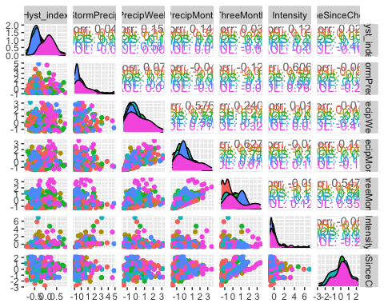

ggsave("pairs1.pdf",  
 width = 10, height = 10)

HI_FI_fDOM_MOOS <- subset(HI_FI_fDOM, site.ID == "MOOS")  
HI_FI_fDOM_FRCH <- subset(HI_FI_fDOM, site.ID == "FRCH")  
HI_FI_fDOM_CARI <- subset(HI_FI_fDOM, site.ID == "CARI")  
HI_FI_fDOM_POKE <- subset(HI_FI_fDOM, site.ID == "POKE")  
HI_FI_fDOM_VAUL <- subset(HI_FI_fDOM, site.ID == "VAUL")  
HI_FI_fDOM_STRT <- subset(HI_FI_fDOM, site.ID == "STRT")  
  
MOOS.model <- lm(Hyst_index ~ StormPrecip + PrecipWeek + PrecipMonth + TimeSinceChena, data = HI_FI_fDOM_MOOS)  
  
FRCH.model <- lm(Hyst_index ~ StormPrecip + PrecipWeek + PrecipMonth + TimeSinceChena, data = HI_FI_fDOM_FRCH)  
  
CARI.model <- lm(Hyst_index ~ StormPrecip + PrecipWeek + PrecipMonth + TimeSinceChena, data = HI_FI_fDOM_CARI)  
  
POKE.model <- lm(Hyst_index ~ StormPrecip + PrecipWeek + PrecipMonth + TimeSinceChena, data = HI_FI_fDOM_POKE)  
  
VAUL.model <- lm(Hyst_index ~ StormPrecip + PrecipWeek + PrecipMonth + TimeSinceChena, data = HI_FI_fDOM_VAUL)  
  
STRT.model <- lm(Hyst_index ~ StormPrecip + PrecipWeek + PrecipMonth + TimeSinceChena, data = HI_FI_fDOM_STRT)  
  
Plot_1 <- plot_summs(MOOS.model, FRCH.model,   
 CARI.model, POKE.model,   
 VAUL.model, STRT.model, scale = TRUE,  
 model.names = c("MOOS", "FRCH", "CARI", "POKE", "VAUL", "STRT"),  
 colors = c("#A6761D", "#FF7F00","#3288BD", "#6A3D9A", "#E7298A", "#66C2A5"))

## Loading required namespace: broom.mixed  
## Loading required namespace: broom.mixed  
## Loading required namespace: broom.mixed  
## Loading required namespace: broom.mixed  
## Loading required namespace: broom.mixed  
## Loading required namespace: broom.mixed

Plot_1 +   
 xlab("Coefficient estimate") + ylab("") +  
 geom_vline(xintercept = 0,  
 colour = "grey80",  
 linetype = 1) +   
scale_y_discrete(labels= c("Seasonality",   
 "Precipitation Month",   
 "Precipitation Week",  
 "Storm Precipitation")) +  
 theme_bw()

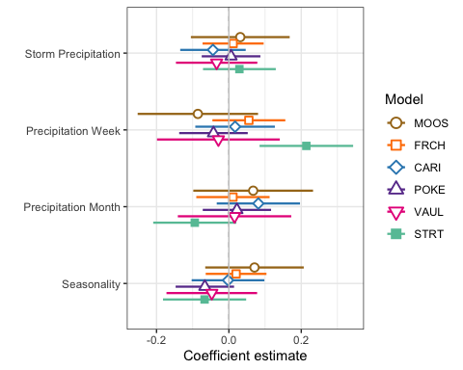

ggsave(path = "~/Documents/Storms_clean_repo/plots/Coefficient_Plots/HI",   
 filename = "HI_fDOM.pdf",  
 width = 7, height = 7)

M1 <- lmer(Hyst_index ~ StormPrecip + PrecipWeek + PrecipMonth + TimeSinceChena + (1|site.ID), data = HI_FI_fDOM)  
  
pr <- ggpredict(M1)  
  
plot(pr, add.data = TRUE)

## $StormPrecip

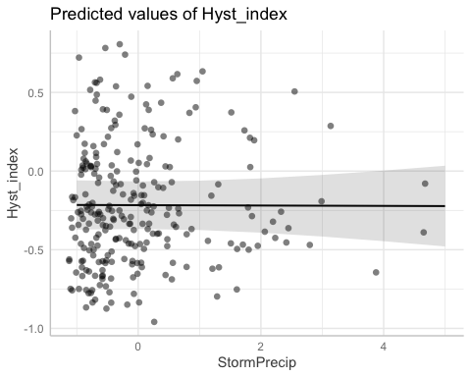

##   
## $PrecipWeek

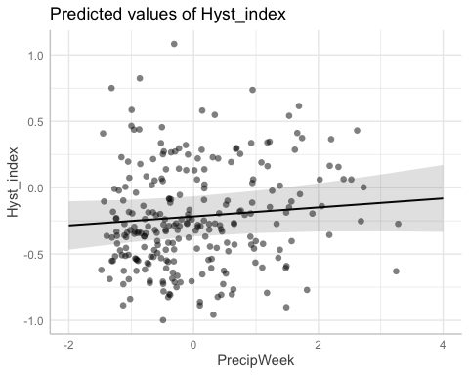

##   
## $PrecipMonth

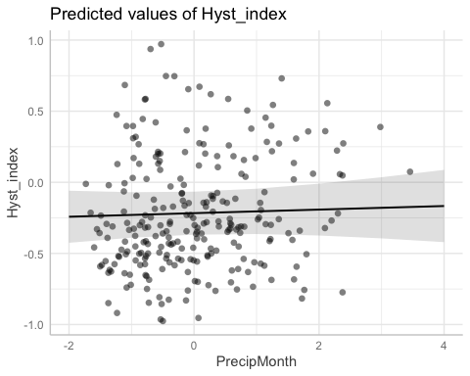

##   
## $TimeSinceChena

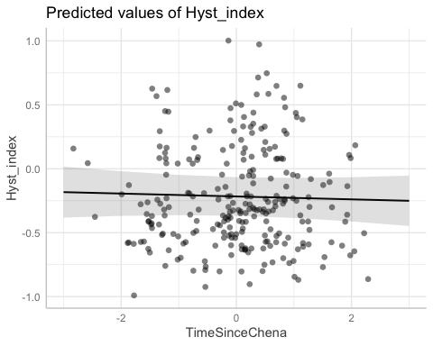

# partial residual plot test to get each site by color   
mo <- ggpredict(MOOS.model)  
plot(mo, add.data = TRUE)

## $StormPrecip

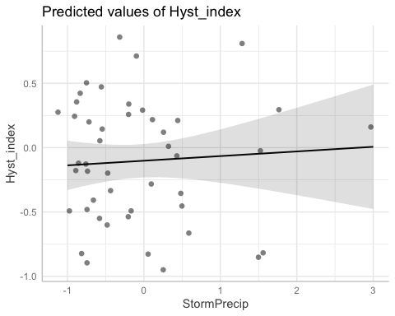

##   
## $PrecipWeek

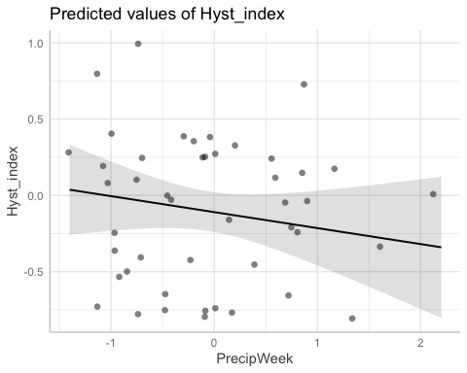

##   
## $PrecipMonth

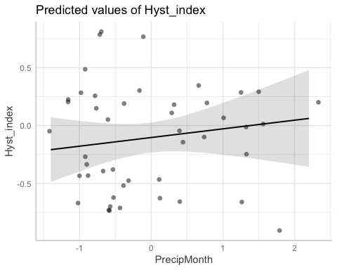

##   
## $TimeSinceChena

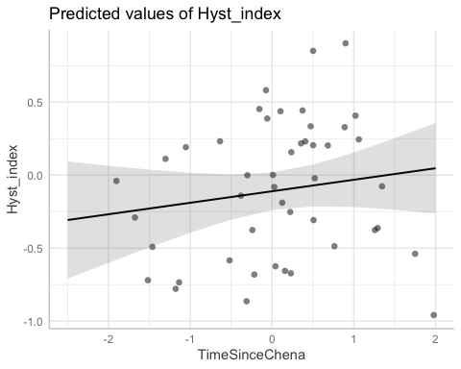

fr <- ggpredict(FRCH.model)  
plot(fr, add.data = TRUE)

## $StormPrecip

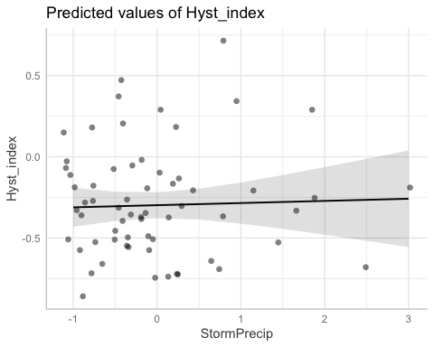

##   
## $PrecipWeek

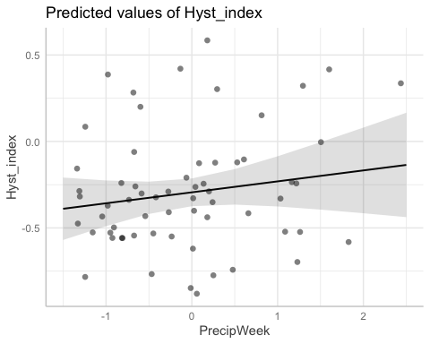

##   
## $PrecipMonth

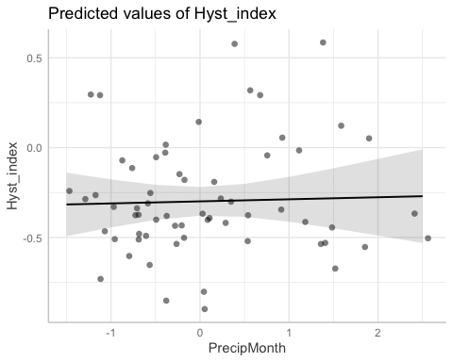

##   
## $TimeSinceChena

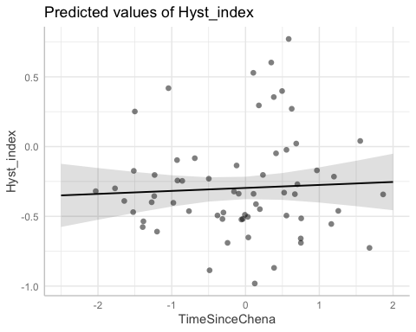

ca <- ggpredict(CARI.model)  
plot(ca, add.data = TRUE)

## $StormPrecip

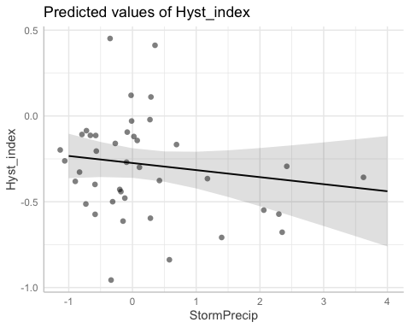

##   
## $PrecipWeek

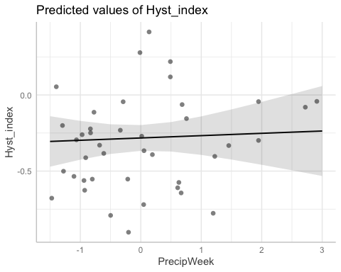

##   
## $PrecipMonth

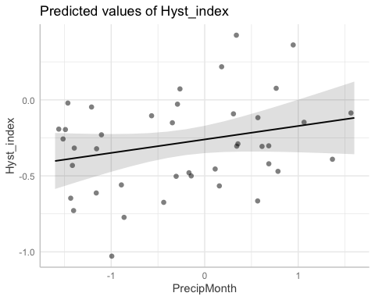

##   
## $TimeSinceChena

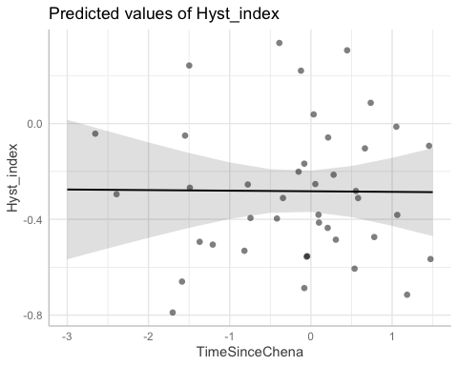

po <- ggpredict(POKE.model)  
plot(po, add.data = TRUE)

## $StormPrecip

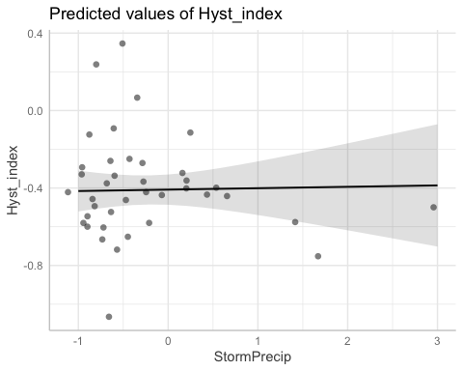

##   
## $PrecipWeek

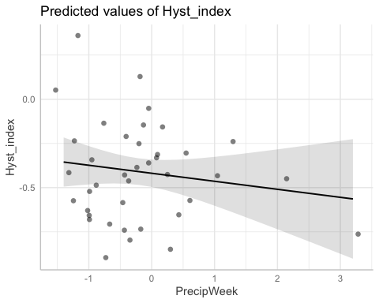

##   
## $PrecipMonth

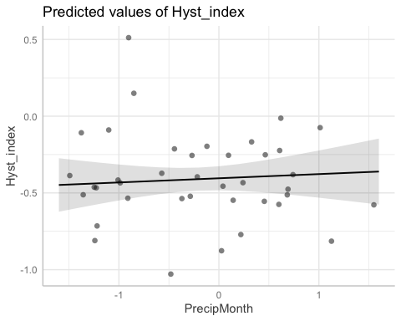

##   
## $TimeSinceChena

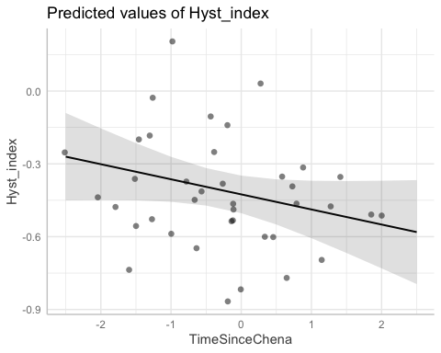

va <- ggpredict(VAUL.model)  
plot(va, add.data = TRUE)

## $StormPrecip

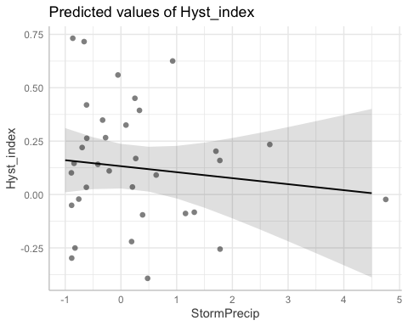

##   
## $PrecipWeek

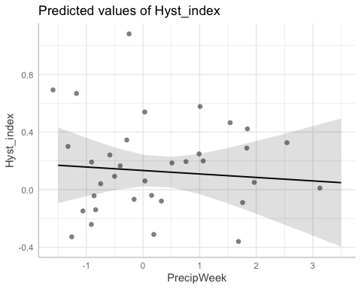

##   
## $PrecipMonth

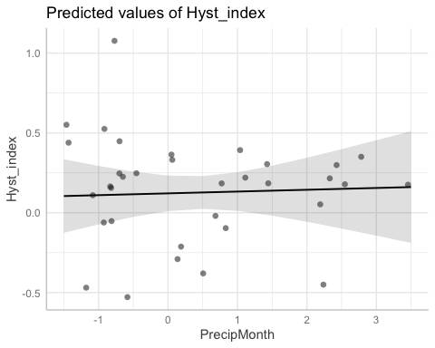

##   
## $TimeSinceChena

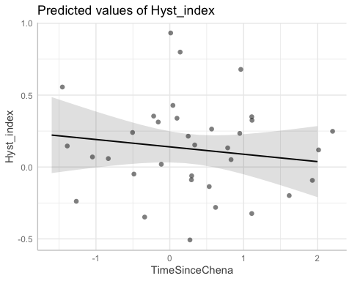

st <- ggpredict(STRT.model)  
plot(st, add.data = TRUE)

## $StormPrecip

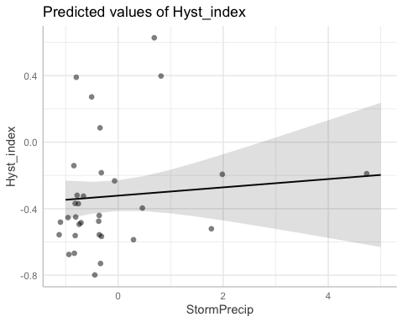

##   
## $PrecipWeek

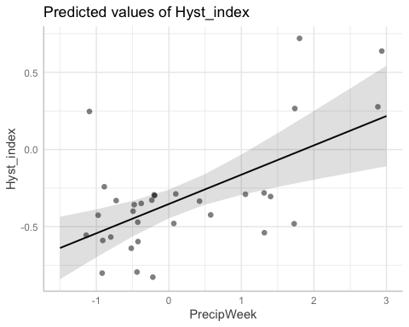

##   
## $PrecipMonth

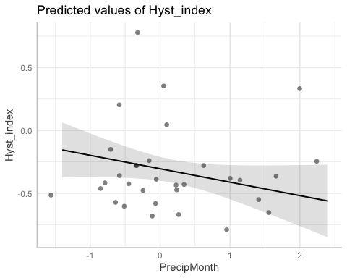

##   
## $TimeSinceChena

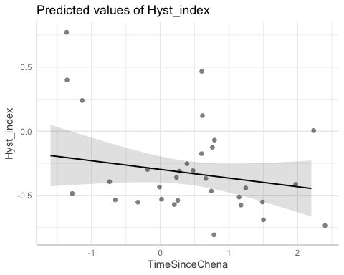

# diagnostic plots

summary(M1)

## Linear mixed model fit by REML ['lmerMod']  
## Formula:   
## Hyst_index ~ StormPrecip + PrecipWeek + PrecipMonth + TimeSinceChena +   
## (1 | site.ID)  
## Data: HI_FI_fDOM  
##   
## REML criterion at convergence: 190.7  
##   
## Scaled residuals:   
## Min 1Q Median 3Q Max   
## -2.2721 -0.6113 -0.1059 0.5061 2.9844   
##   
## Random effects:  
## Groups Name Variance Std.Dev.  
## site.ID (Intercept) 0.03307 0.1819   
## Residual 0.10691 0.3270   
## Number of obs: 255, groups: site.ID, 6  
##   
## Fixed effects:  
## Estimate Std. Error t value  
## (Intercept) -0.216915 0.077148 -2.812  
## StormPrecip -0.001164 0.021124 -0.055  
## PrecipWeek 0.033946 0.025855 1.313  
## PrecipMonth 0.012558 0.026142 0.480  
## TimeSinceChena -0.011314 0.021840 -0.518  
##   
## Correlation of Fixed Effects:  
## (Intr) StrmPr PrcpWk PrcpMn  
## StormPrecip 0.002   
## PrecipWeek -0.002 -0.110   
## PrecipMonth -0.005 0.102 -0.592   
## TimeSincChn -0.010 0.050 0.155 -0.153

plot(M1, type=c("p","smooth"), col.line=1)

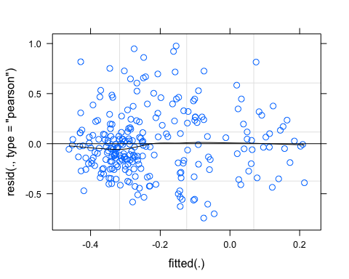

lattice::qqmath(M1)

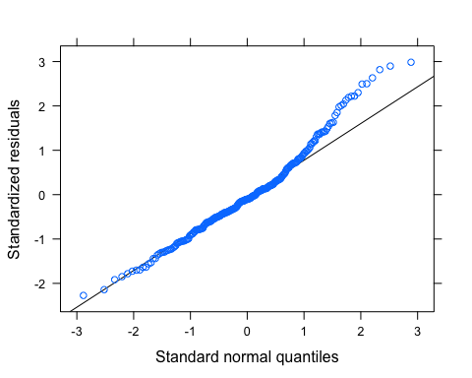

plot(M1, rstudent(.) ~ hatvalues(.))

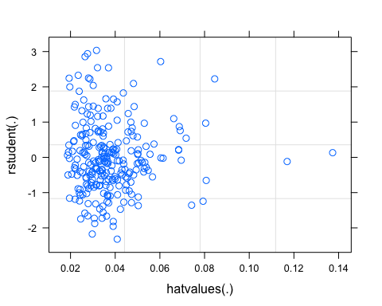

# SPC

SPC_data <- HI_FI_SPC[,c("Hyst_index", "site.ID", "StormPrecip", "PrecipWeek", "PrecipMonth", "ThreeMonth", "Intensity", "TimeSinceChena", "pf", "burn", "year")]  
SPC_data <- na.omit(SPC_data) # 250 to 247 rows   
  
SPC_data <- SPC_data[, c(1,3,4,5,6,7,8,2,9,10,11)]  
cor(SPC_data[,c(1:7)])

## Hyst_index StormPrecip PrecipWeek PrecipMonth ThreeMonth  
## Hyst_index 1.00000000 0.17996371 -0.225423657 -0.13590276 0.03305552  
## StormPrecip 0.17996371 1.00000000 0.065159634 -0.06084880 -0.12003304  
## PrecipWeek -0.22542366 0.06515963 1.000000000 0.58290251 0.24516335  
## PrecipMonth -0.13590276 -0.06084880 0.582902514 1.00000000 0.63795732  
## ThreeMonth 0.03305552 -0.12003304 0.245163348 0.63795732 1.00000000  
## Intensity 0.15682392 0.62057856 -0.002881222 -0.05752164 -0.10543087  
## TimeSinceChena 0.19953662 -0.06554041 -0.075659042 0.12176258 0.54794998  
## Intensity TimeSinceChena  
## Hyst_index 0.156823923 0.19953662  
## StormPrecip 0.620578560 -0.06554041  
## PrecipWeek -0.002881222 -0.07565904  
## PrecipMonth -0.057521643 0.12176258  
## ThreeMonth -0.105430868 0.54794998  
## Intensity 1.000000000 -0.05893247  
## TimeSinceChena -0.058932473 1.00000000

ggpairs(SPC_data,  
 columns = 1:7,  
 ggplot2::aes(colour = site.ID))

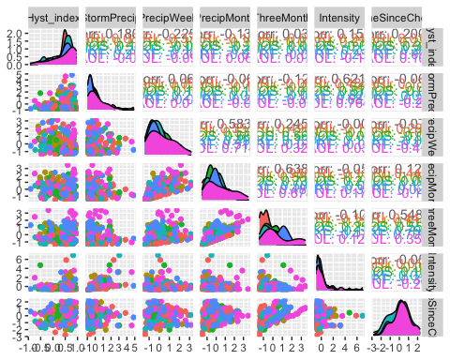

ggsave("pairs1.pdf",  
 width = 10, height = 10)

HI_FI_SPC_MOOS <- subset(HI_FI_SPC, site.ID == "MOOS")  
HI_FI_SPC_FRCH <- subset(HI_FI_SPC, site.ID == "FRCH")  
HI_FI_SPC_CARI <- subset(HI_FI_SPC, site.ID == "CARI")  
HI_FI_SPC_POKE <- subset(HI_FI_SPC, site.ID == "POKE")  
HI_FI_SPC_VAUL <- subset(HI_FI_SPC, site.ID == "VAUL")  
HI_FI_SPC_STRT <- subset(HI_FI_SPC, site.ID == "STRT")  
  
MOOS.model <- lm(Hyst_index ~ StormPrecip + PrecipWeek + PrecipMonth + TimeSinceChena, data = HI_FI_SPC_MOOS)  
  
FRCH.model <- lm(Hyst_index ~ StormPrecip + PrecipWeek + PrecipMonth + TimeSinceChena, data = HI_FI_SPC_FRCH)  
  
CARI.model <- lm(Hyst_index ~ StormPrecip + PrecipWeek + PrecipMonth + TimeSinceChena, data = HI_FI_SPC_CARI)  
  
POKE.model <- lm(Hyst_index ~ StormPrecip + PrecipWeek + PrecipMonth + TimeSinceChena, data = HI_FI_SPC_POKE)  
  
VAUL.model <- lm(Hyst_index ~ StormPrecip + PrecipWeek + PrecipMonth + TimeSinceChena, data = HI_FI_SPC_VAUL)  
  
STRT.model <- lm(Hyst_index ~ StormPrecip + PrecipWeek + PrecipMonth + TimeSinceChena, data = HI_FI_SPC_STRT)  
  
Plot_1 <- plot_summs(MOOS.model, FRCH.model,   
 CARI.model, POKE.model,   
 VAUL.model, STRT.model, scale = TRUE,  
 model.names = c("MOOS", "FRCH", "CARI", "POKE", "VAUL", "STRT"),  
 colors = c("#A6761D", "#FF7F00","#3288BD", "#6A3D9A", "#E7298A", "#66C2A5"))

## Loading required namespace: broom.mixed  
## Loading required namespace: broom.mixed  
## Loading required namespace: broom.mixed  
## Loading required namespace: broom.mixed  
## Loading required namespace: broom.mixed  
## Loading required namespace: broom.mixed

Plot_1 +   
 xlab("Coefficient estimate") + ylab("") +  
 geom_vline(xintercept = 0,  
 colour = "grey80",  
 linetype = 1) +   
scale_y_discrete(labels= c("Seasonality",   
 "Precipitation Month",   
 "Precipitation Week",  
 "Storm Precipitation")) +  
 theme_bw()

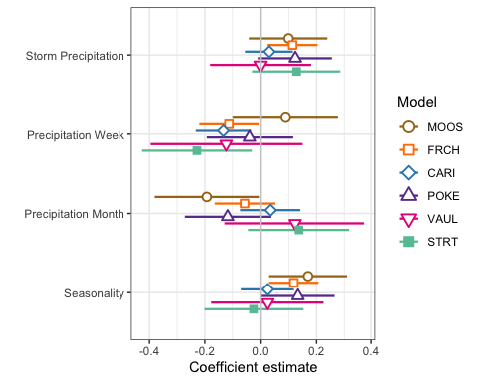

ggsave(path = "~/Documents/Storms_clean_repo/plots/Coefficient_Plots/HI",   
 filename = "HI_SPC.pdf",  
 width = 7, height = 7)

M1 <- lmer(Hyst_index ~ StormPrecip + PrecipWeek + PrecipMonth + TimeSinceChena + (1|site.ID), data = HI_FI_SPC)

## boundary (singular) fit: see ?isSingular

pr <- ggpredict(M1)  
  
plot(pr, add.data = TRUE)

## $StormPrecip

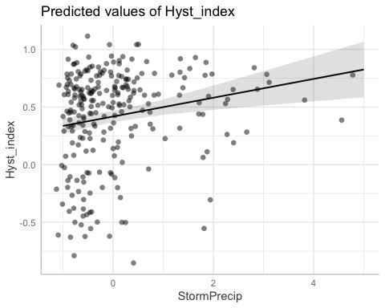

##   
## $PrecipWeek

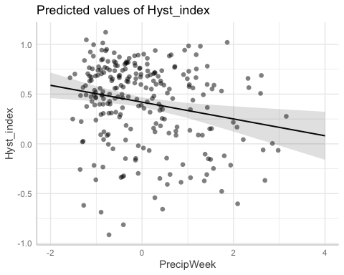

##   
## $PrecipMonth

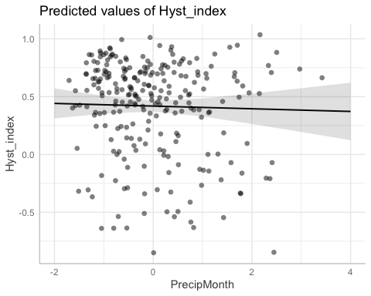

##   
## $TimeSinceChena

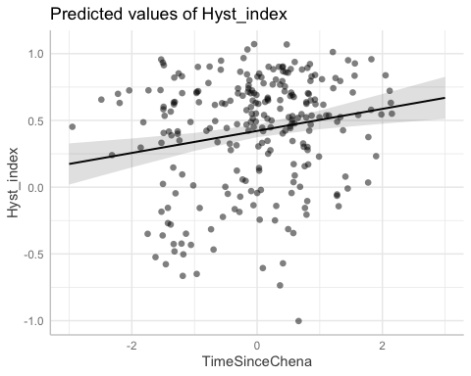

# partial residual plot test to get each site by color   
mo <- ggpredict(MOOS.model)  
plot(mo, add.data = TRUE)

## $StormPrecip

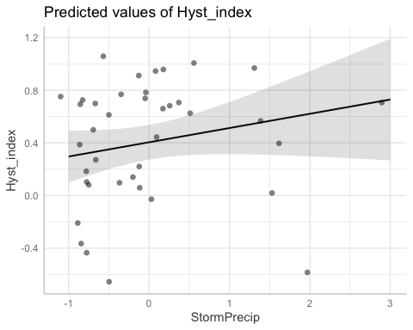

##   
## $PrecipWeek

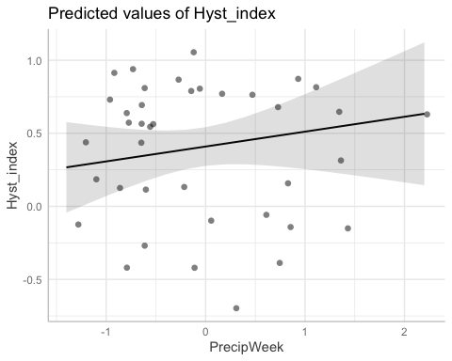

##   
## $PrecipMonth

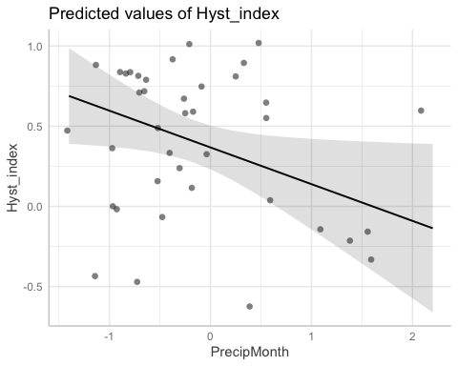

##   
## $TimeSinceChena

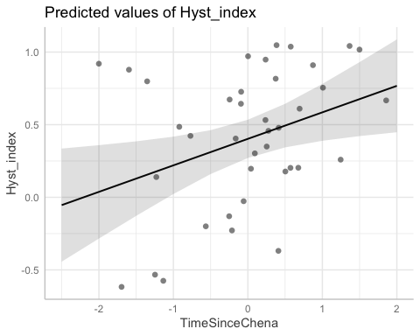

fr <- ggpredict(FRCH.model)  
plot(fr, add.data = TRUE)

## $StormPrecip

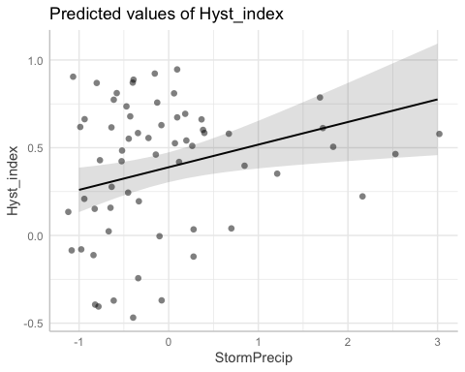

##   
## $PrecipWeek

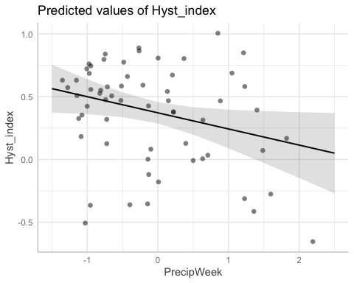

##   
## $PrecipMonth

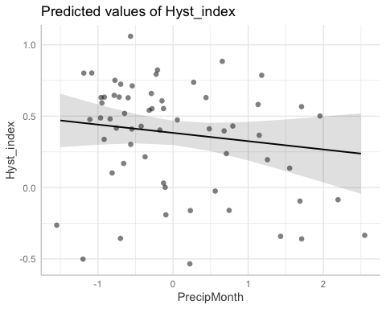

##   
## $TimeSinceChena

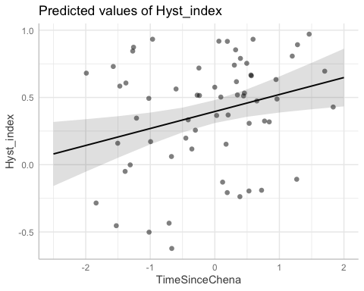

ca <- ggpredict(CARI.model)  
plot(ca, add.data = TRUE)

## $StormPrecip

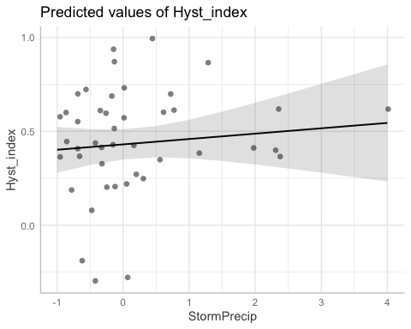

##   
## $PrecipWeek

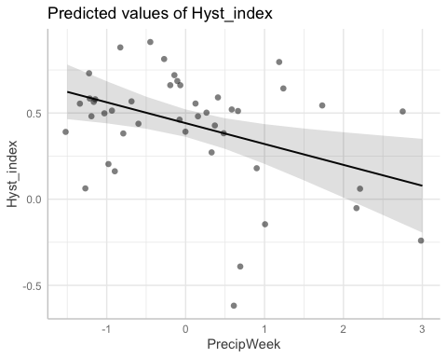

##   
## $PrecipMonth

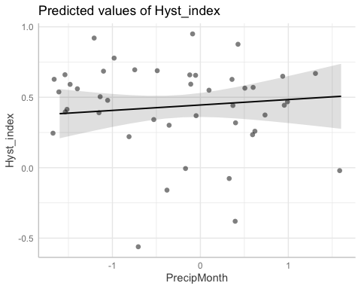

##   
## $TimeSinceChena

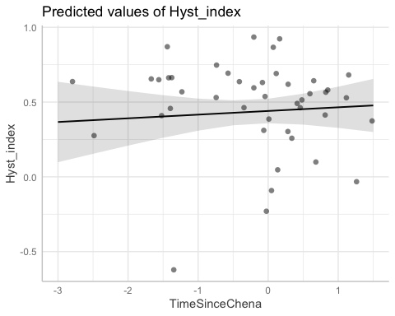

po <- ggpredict(POKE.model)  
plot(po, add.data = TRUE)

## $StormPrecip

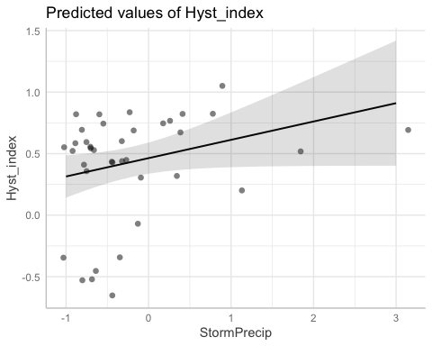

##   
## $PrecipWeek

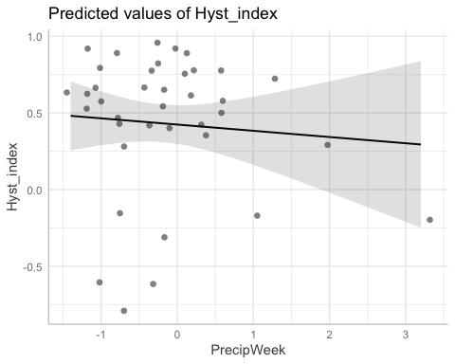

##   
## $PrecipMonth

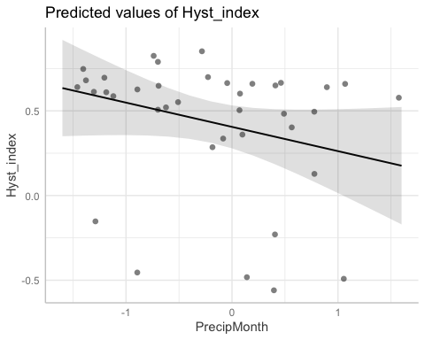

##   
## $TimeSinceChena

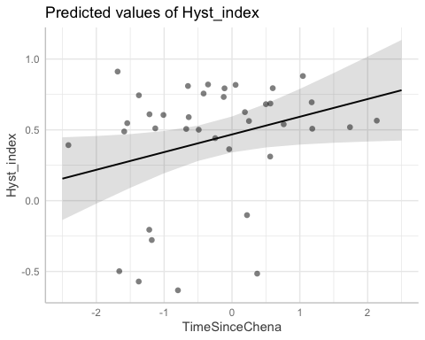

va <- ggpredict(VAUL.model)  
plot(va, add.data = TRUE)

## $StormPrecip

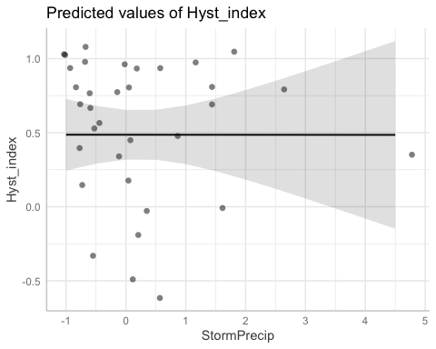

##   
## $PrecipWeek

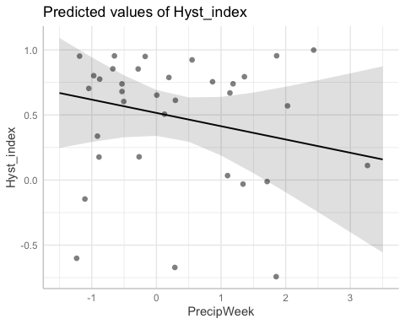

##   
## $PrecipMonth

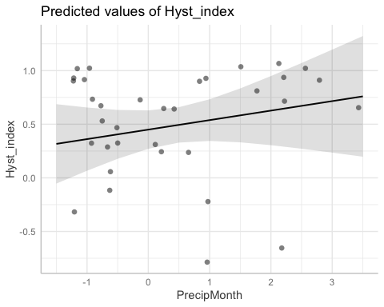

##   
## $TimeSinceChena

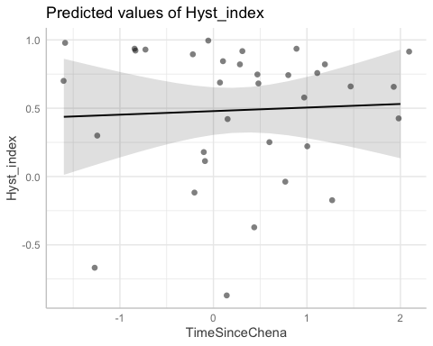

st <- ggpredict(STRT.model)  
plot(st, add.data = TRUE)

## $StormPrecip

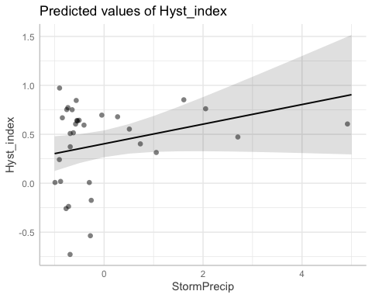

##   
## $PrecipWeek

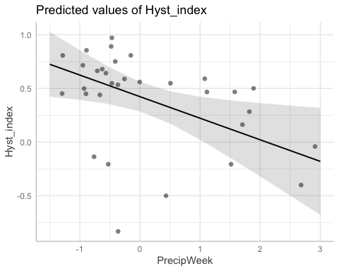

##   
## $PrecipMonth

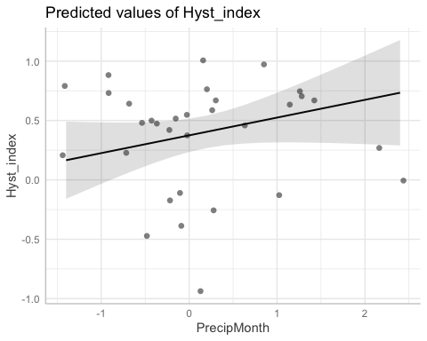

##   
## $TimeSinceChena

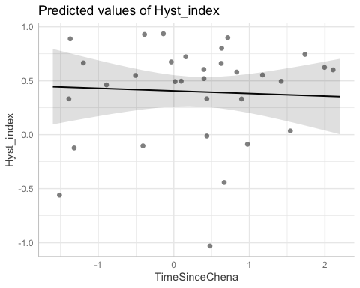

# diagnostic plots

summary(M1)

## Linear mixed model fit by REML ['lmerMod']  
## Formula:   
## Hyst_index ~ StormPrecip + PrecipWeek + PrecipMonth + TimeSinceChena +   
## (1 | site.ID)  
## Data: HI_FI_SPC  
##   
## REML criterion at convergence: 249.4  
##   
## Scaled residuals:   
## Min 1Q Median 3Q Max   
## -3.4939 -0.5780 0.2333 0.7091 1.7899   
##   
## Random effects:  
## Groups Name Variance Std.Dev.  
## site.ID (Intercept) 0.0000 0.0000   
## Residual 0.1456 0.3816   
## Number of obs: 249, groups: site.ID, 6  
##   
## Fixed effects:  
## Estimate Std. Error t value  
## (Intercept) 0.42111 0.02420 17.401  
## StormPrecip 0.08156 0.02415 3.377  
## PrecipWeek -0.08453 0.03025 -2.795  
## PrecipMonth -0.01159 0.03101 -0.374  
## TimeSinceChena 0.08254 0.02526 3.268  
##   
## Correlation of Fixed Effects:  
## (Intr) StrmPr PrcpWk PrcpMn  
## StormPrecip -0.006   
## PrecipWeek -0.014 -0.117   
## PrecipMonth 0.016 0.110 -0.607   
## TimeSincChn 0.030 0.036 0.170 -0.203  
## optimizer (nloptwrap) convergence code: 0 (OK)  
## boundary (singular) fit: see ?isSingular

plot(M1, type=c("p","smooth"), col.line=1)

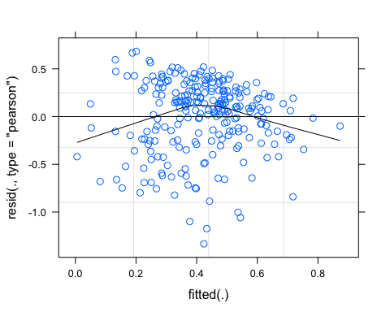

lattice::qqmath(M1)

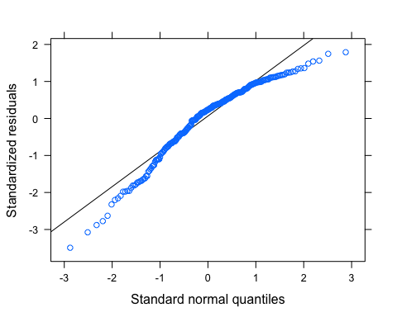

plot(M1, rstudent(.) ~ hatvalues(.))

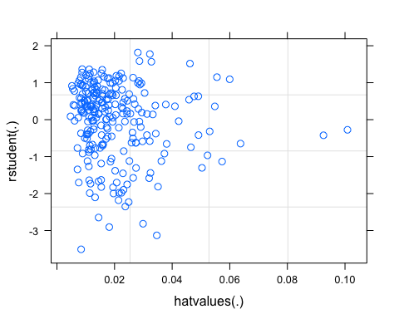 qq plot doesnt look the best

turb_data <- HI_FI_turb[,c("Hyst_index", "site.ID", "StormPrecip", "PrecipWeek", "PrecipMonth", "ThreeMonth", "Intensity", "TimeSinceChena", "pf", "burn", "year")]  
turb_data <- na.omit(turb_data) # 257 to 254 rows   
  
turb_data <- turb_data[, c(1,3,4,5,6,7,8,2,9,10,11)]  
cor(turb_data[,c(1:7)])

## Hyst_index StormPrecip PrecipWeek PrecipMonth ThreeMonth  
## Hyst_index 1.000000000 0.07387307 0.181410361 0.02832855 -0.02304822  
## StormPrecip 0.073873068 1.00000000 0.068637938 -0.05877246 -0.12936775  
## PrecipWeek 0.181410361 0.06863794 1.000000000 0.57085578 0.23249646  
## PrecipMonth 0.028328550 -0.05877246 0.570855780 1.00000000 0.63327922  
## ThreeMonth -0.023048216 -0.12936775 0.232496459 0.63327922 1.00000000  
## Intensity -0.001893757 0.61881766 0.006930872 -0.03514412 -0.09692325  
## TimeSinceChena -0.073656510 -0.07159136 -0.086192926 0.11383081 0.54893967  
## Intensity TimeSinceChena  
## Hyst_index -0.001893757 -0.07365651  
## StormPrecip 0.618817657 -0.07159136  
## PrecipWeek 0.006930872 -0.08619293  
## PrecipMonth -0.035144122 0.11383081  
## ThreeMonth -0.096923250 0.54893967  
## Intensity 1.000000000 -0.05484823  
## TimeSinceChena -0.054848231 1.00000000

ggpairs(SPC_data,  
 columns = 1:7,  
 ggplot2::aes(colour = site.ID))



ggsave("pairs1.pdf",  
 width = 10, height = 10)

HI_FI_turb_MOOS <- subset(HI_FI_turb, site.ID == "MOOS")  
HI_FI_turb_FRCH <- subset(HI_FI_turb, site.ID == "FRCH")  
HI_FI_turb_CARI <- subset(HI_FI_turb, site.ID == "CARI")  
HI_FI_turb_POKE <- subset(HI_FI_turb, site.ID == "POKE")  
HI_FI_turb_VAUL <- subset(HI_FI_turb, site.ID == "VAUL")  
HI_FI_turb_STRT <- subset(HI_FI_turb, site.ID == "STRT")  
  
MOOS.model <- lm(Hyst_index ~ StormPrecip + PrecipWeek + PrecipMonth + TimeSinceChena, data = HI_FI_turb_MOOS)  
  
FRCH.model <- lm(Hyst_index ~ StormPrecip + PrecipWeek + PrecipMonth + TimeSinceChena, data = HI_FI_turb_FRCH)  
  
CARI.model <- lm(Hyst_index ~ StormPrecip + PrecipWeek + PrecipMonth + TimeSinceChena, data = HI_FI_turb_CARI)  
  
POKE.model <- lm(Hyst_index ~ StormPrecip + PrecipWeek + PrecipMonth + TimeSinceChena, data = HI_FI_turb_POKE)  
  
VAUL.model <- lm(Hyst_index ~ StormPrecip + PrecipWeek + PrecipMonth + TimeSinceChena, data = HI_FI_turb_VAUL)  
  
STRT.model <- lm(Hyst_index ~ StormPrecip + PrecipWeek + PrecipMonth + TimeSinceChena, data = HI_FI_turb_STRT)  
  
Plot_1 <- plot_summs(MOOS.model, FRCH.model,   
 CARI.model, POKE.model,   
 VAUL.model, STRT.model, scale = TRUE,  
 model.names = c("MOOS", "FRCH", "CARI", "POKE", "VAUL", "STRT"),  
 colors = c("#A6761D", "#FF7F00","#3288BD", "#6A3D9A", "#E7298A", "#66C2A5"))

## Loading required namespace: broom.mixed  
## Loading required namespace: broom.mixed  
## Loading required namespace: broom.mixed  
## Loading required namespace: broom.mixed  
## Loading required namespace: broom.mixed  
## Loading required namespace: broom.mixed

Plot_1 +   
 xlab("Coefficient estimate") + ylab("") +  
 geom_vline(xintercept = 0,  
 colour = "grey80",  
 linetype = 1) +   
scale_y_discrete(labels= c("Seasonality",   
 "Precipitation Month",   
 "Precipitation Week",  
 "Storm Precipitation")) +  
 theme_bw()

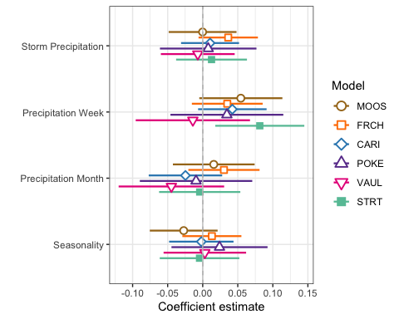

ggsave(path = "~/Documents/Storms_clean_repo/plots/Coefficient_Plots/HI",   
 filename = "HI_turb.pdf",  
 width = 7, height = 7)

M1 <- lmer(Hyst_index ~ StormPrecip + PrecipWeek + PrecipMonth + TimeSinceChena + (1|site.ID), data = HI_FI_turb)  
pr <- ggpredict(M1)  
  
plot(pr, add.data = TRUE)

## $StormPrecip

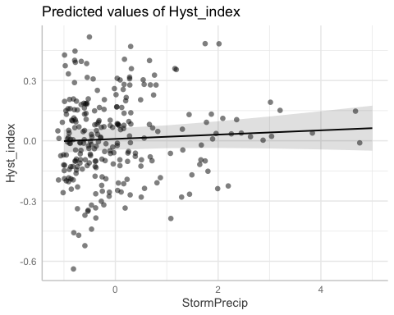

##   
## $PrecipWeek

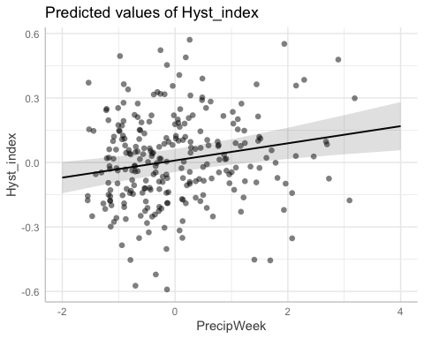

##   
## $PrecipMonth

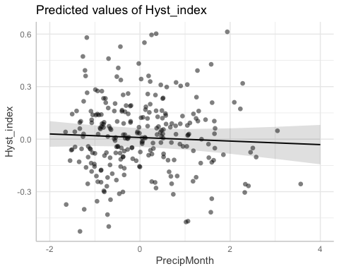

##   
## $TimeSinceChena

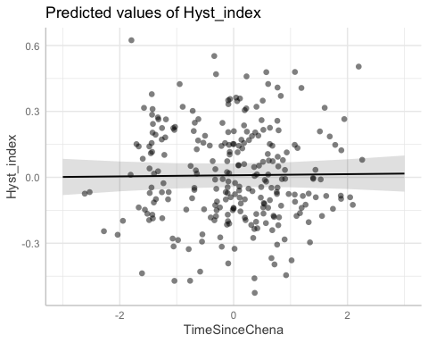

# partial residual plot test to get each site by color   
mo <- ggpredict(MOOS.model)  
plot(mo, add.data = TRUE)

## $StormPrecip

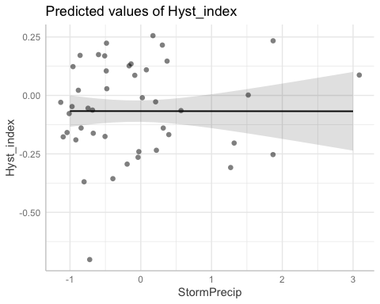

##   
## $PrecipWeek

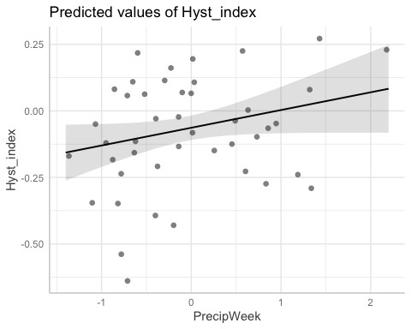

##   
## $PrecipMonth

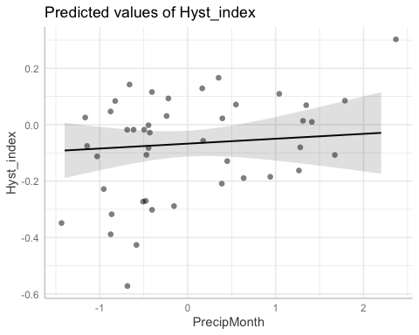

##   
## $TimeSinceChena

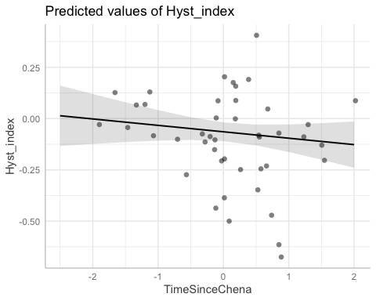

fr <- ggpredict(FRCH.model)  
plot(fr, add.data = TRUE)

## $StormPrecip

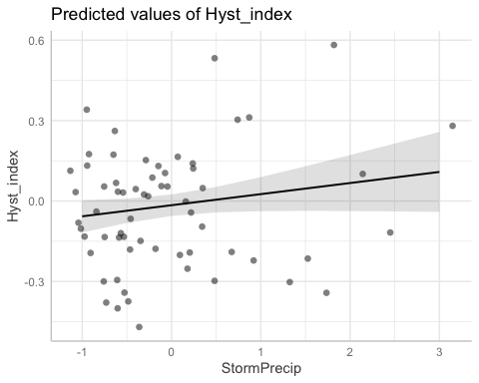

##   
## $PrecipWeek

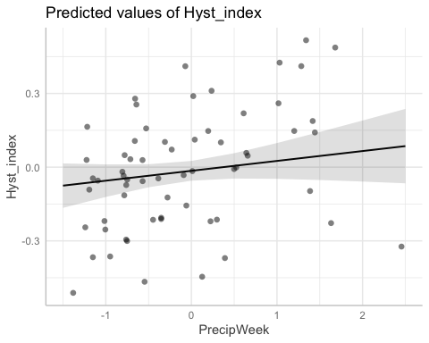

##   
## $PrecipMonth

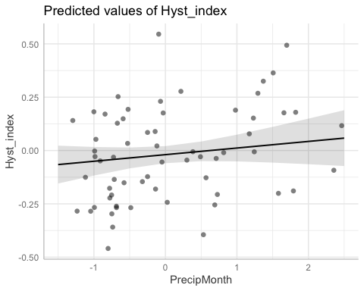

##   
## $TimeSinceChena

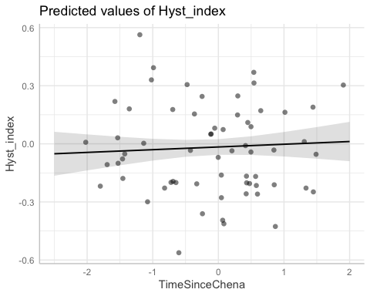

ca <- ggpredict(CARI.model)  
plot(ca, add.data = TRUE)

## $StormPrecip

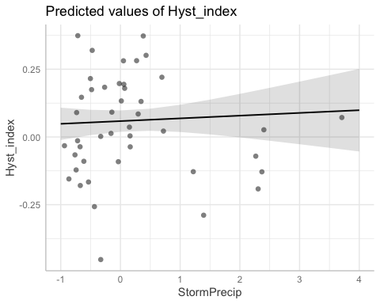

##   
## $PrecipWeek

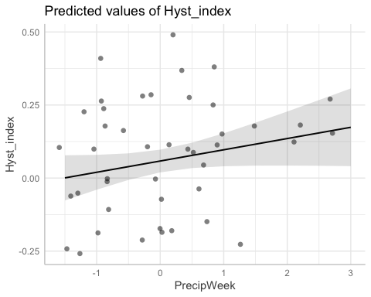

##   
## $PrecipMonth

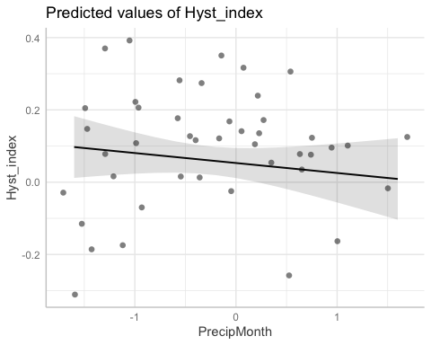

##   
## $TimeSinceChena

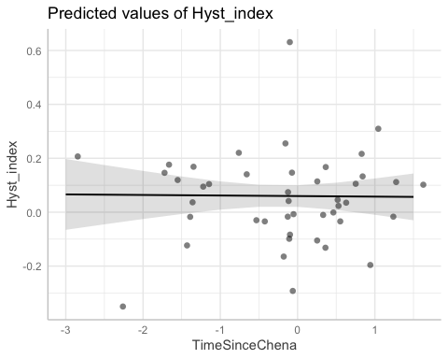

po <- ggpredict(POKE.model)  
plot(po, add.data = TRUE)

## $StormPrecip

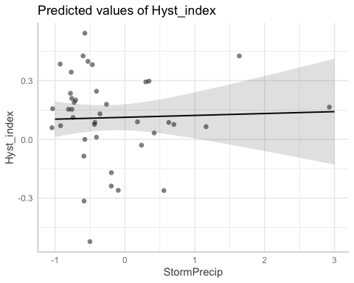

##   
## $PrecipWeek

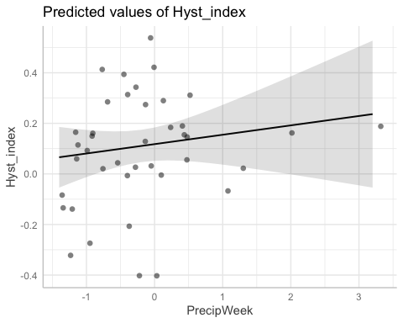

##   
## $PrecipMonth

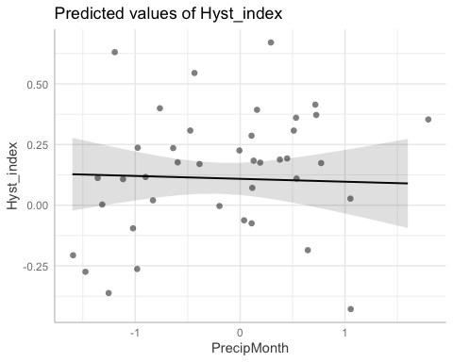

##   
## $TimeSinceChena

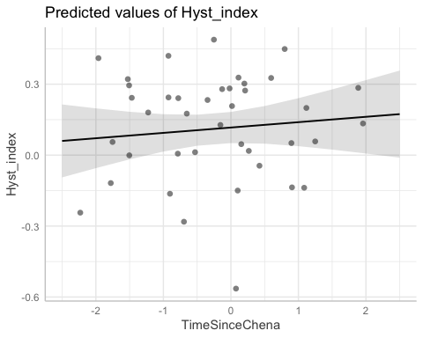

va <- ggpredict(VAUL.model)  
plot(va, add.data = TRUE)

## $StormPrecip

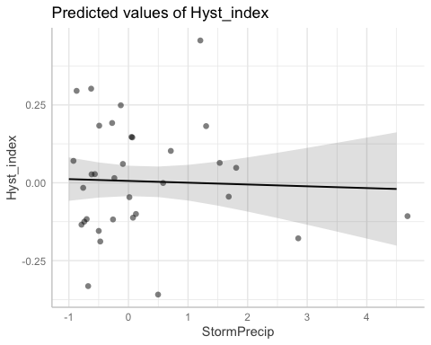

##   
## $PrecipWeek

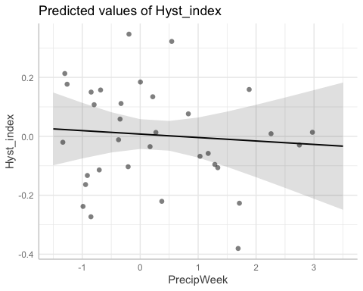

##   
## $PrecipMonth

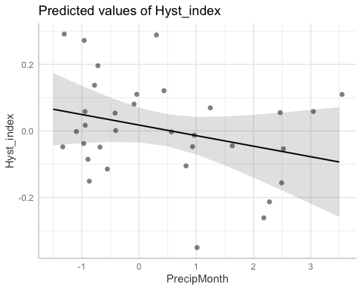

##   
## $TimeSinceChena

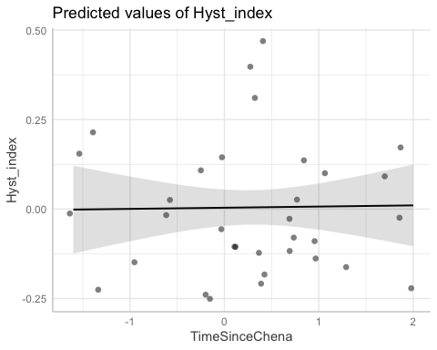

st <- ggpredict(STRT.model)  
plot(st, add.data = TRUE)

## $StormPrecip

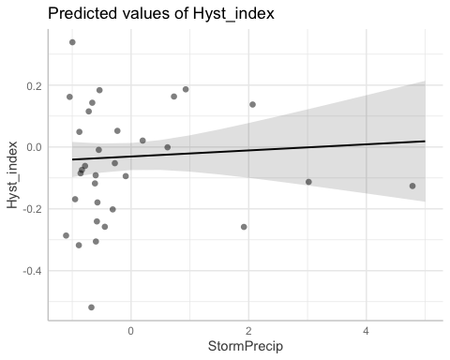

##   
## $PrecipWeek

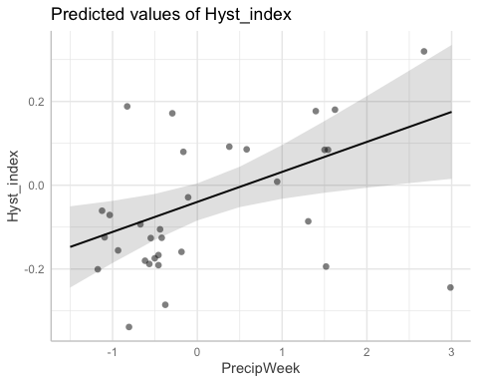

##   
## $PrecipMonth

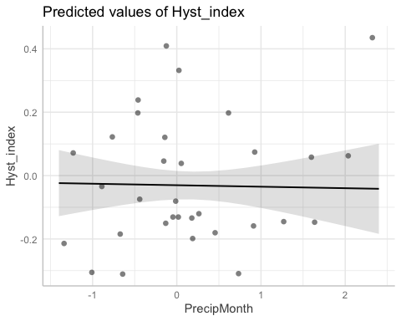

##   
## $TimeSinceChena

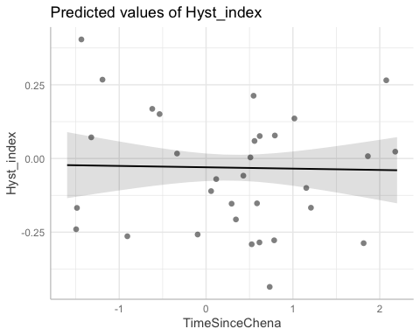

# diagnostic plots

summary(M1)

## Linear mixed model fit by REML ['lmerMod']  
## Formula:   
## Hyst_index ~ StormPrecip + PrecipWeek + PrecipMonth + TimeSinceChena +   
## (1 | site.ID)  
## Data: HI_FI_turb  
##   
## REML criterion at convergence: -175.1  
##   
## Scaled residuals:   
## Min 1Q Median 3Q Max   
## -3.8553 -0.6401 0.0307 0.5976 2.6512   
##   
## Random effects:  
## Groups Name Variance Std.Dev.  
## site.ID (Intercept) 0.003844 0.0620   
## Residual 0.025142 0.1586   
## Number of obs: 256, groups: site.ID, 6  
##   
## Fixed effects:  
## Estimate Std. Error t value  
## (Intercept) 0.009458 0.027264 0.347  
## StormPrecip 0.010690 0.010064 1.062  
## PrecipWeek 0.039922 0.012588 3.171  
## PrecipMonth -0.010145 0.012666 -0.801  
## TimeSinceChena 0.002554 0.010656 0.240  
##   
## Correlation of Fixed Effects:  
## (Intr) StrmPr PrcpWk PrcpMn  
## StormPrecip -0.002   
## PrecipWeek -0.001 -0.105   
## PrecipMonth -0.007 0.109 -0.594   
## TimeSincChn -0.003 0.055 0.176 -0.175

plot(M1, type=c("p","smooth"), col.line=1)

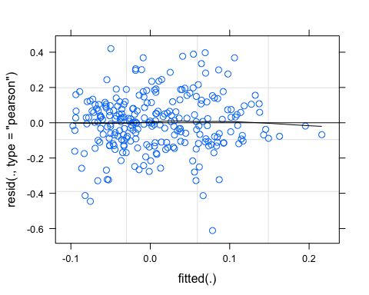

lattice::qqmath(M1)

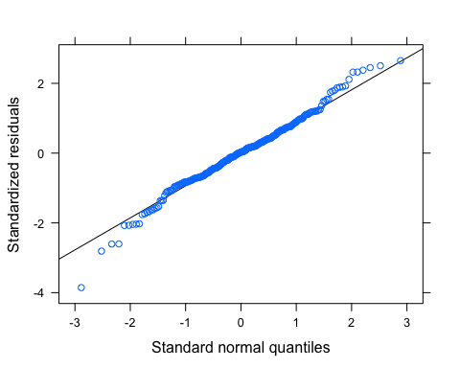

plot(M1, rstudent(.) ~ hatvalues(.))

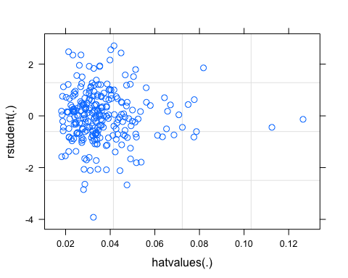

BETA

NO3_data <- HI_FI_NO3[,c("Beta_index", "site.ID", "StormPrecip", "PrecipWeek", "PrecipMonth", "ThreeMonth", "Intensity", "TimeSinceChena", "pf", "burn", "year")]  
NO3_data <- na.omit(NO3_data) # 244 to 236 rows   
  
NO3_data <- NO3_data[, c(1,3,4,5,6,7,8,2,9,10,11)]  
cor(NO3_data[,c(1:7)])

## Beta_index StormPrecip PrecipWeek PrecipMonth ThreeMonth  
## Beta_index 1.000000000 -0.08185507 -0.16721405 -0.08928656 -0.01665628  
## StormPrecip -0.081855073 1.00000000 0.07035227 -0.06870384 -0.13240256  
## PrecipWeek -0.167214051 0.07035227 1.00000000 0.59412993 0.20095411  
## PrecipMonth -0.089286557 -0.06870384 0.59412993 1.00000000 0.58236806  
## ThreeMonth -0.016656281 -0.13240256 0.20095411 0.58236806 1.00000000  
## Intensity 0.006803370 0.64581214 -0.01110439 -0.07837221 -0.15746271  
## TimeSinceChena -0.009005312 -0.08720462 -0.10380518 0.03434696 0.54007911  
## Intensity TimeSinceChena  
## Beta_index 0.00680337 -0.009005312  
## StormPrecip 0.64581214 -0.087204624  
## PrecipWeek -0.01110439 -0.103805179  
## PrecipMonth -0.07837221 0.034346960  
## ThreeMonth -0.15746271 0.540079107  
## Intensity 1.00000000 -0.104661459  
## TimeSinceChena -0.10466146 1.000000000

ggpairs(NO3_data,  
 columns = 1:7,  
 ggplot2::aes(colour = site.ID))

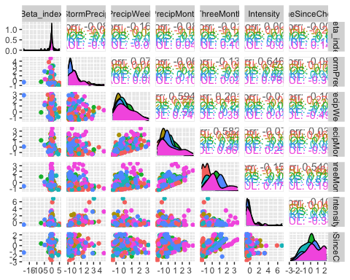

ggsave("pairs1.pdf",  
 width = 10, height = 10)

HI_FI_NO3_MOOS <- subset(HI_FI_NO3, site.ID == "MOOS")  
HI_FI_NO3_FRCH <- subset(HI_FI_NO3, site.ID == "FRCH")  
HI_FI_NO3_CARI <- subset(HI_FI_NO3, site.ID == "CARI")  
HI_FI_NO3_POKE <- subset(HI_FI_NO3, site.ID == "POKE")  
HI_FI_NO3_VAUL <- subset(HI_FI_NO3, site.ID == "VAUL")  
HI_FI_NO3_STRT <- subset(HI_FI_NO3, site.ID == "STRT")  
  
MOOS.model <- lm(Beta_index ~ StormPrecip + PrecipWeek + PrecipMonth + TimeSinceChena, data = HI_FI_NO3_MOOS)  
  
FRCH.model <- lm(Beta_index ~ StormPrecip + PrecipWeek + PrecipMonth + TimeSinceChena, data = HI_FI_NO3_FRCH)  
  
CARI.model <- lm(Beta_index ~ StormPrecip + PrecipWeek + PrecipMonth + TimeSinceChena, data = HI_FI_NO3_CARI)  
  
POKE.model <- lm(Beta_index ~ StormPrecip + PrecipWeek + PrecipMonth + TimeSinceChena, data = HI_FI_NO3_POKE)  
  
VAUL.model <- lm(Beta_index ~ StormPrecip + PrecipWeek + PrecipMonth + TimeSinceChena, data = HI_FI_NO3_VAUL)  
  
STRT.model <- lm(Beta_index ~ StormPrecip + PrecipWeek + PrecipMonth + TimeSinceChena, data = HI_FI_NO3_STRT)  
  
Plot_1 <- plot_summs(MOOS.model, FRCH.model,   
 CARI.model, POKE.model,   
 VAUL.model, STRT.model, scale = TRUE,  
 model.names = c("MOOS", "FRCH", "CARI", "POKE", "VAUL", "STRT"),  
 colors = c("#A6761D", "#FF7F00","#3288BD", "#6A3D9A", "#E7298A", "#66C2A5"))

## Loading required namespace: broom.mixed  
## Loading required namespace: broom.mixed  
## Loading required namespace: broom.mixed  
## Loading required namespace: broom.mixed  
## Loading required namespace: broom.mixed  
## Loading required namespace: broom.mixed

Plot_1 +   
 xlab("Coefficient estimate") + ylab("") +  
 geom_vline(xintercept = 0,  
 colour = "grey80",  
 linetype = 1) +   
scale_y_discrete(labels= c("Seasonality",   
 "Precipitation Month",   
 "Precipitation Week",  
 "Storm Precipitation")) +  
 theme_bw()

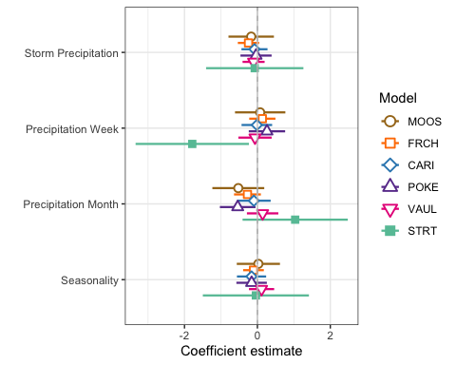

ggsave(path = "~/Documents/Storms_clean_repo/plots/Coefficient_Plots/BETA",   
 filename = "BETA_NO3.pdf",  
 width = 7, height = 7)

M1 <- lmer(Beta_index ~ StormPrecip + PrecipWeek + PrecipMonth + TimeSinceChena + (1|site.ID), data = HI_FI_NO3)  
pr <- ggpredict(M1)  
  
plot(pr, add.data = TRUE)

## $StormPrecip

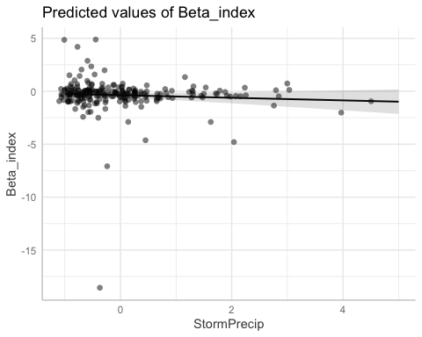

##   
## $PrecipWeek

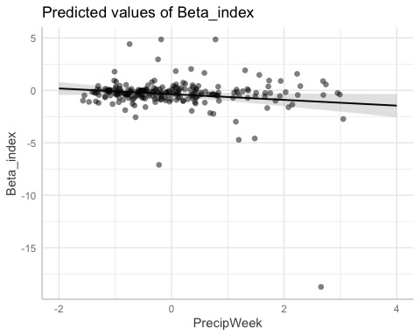

##   
## $PrecipMonth

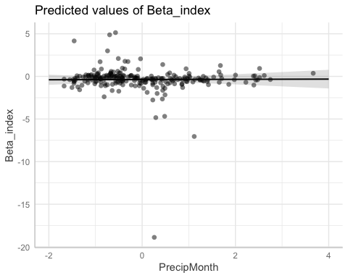

##   
## $TimeSinceChena

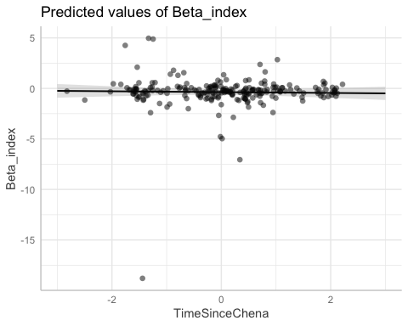

# partial residual plot test to get each site by color   
mo <- ggpredict(MOOS.model)  
plot(mo, add.data = TRUE)

## $StormPrecip

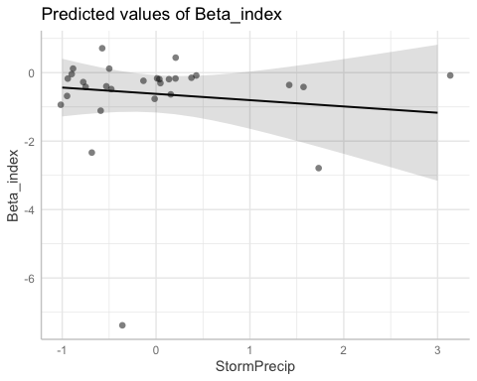

##   
## $PrecipWeek

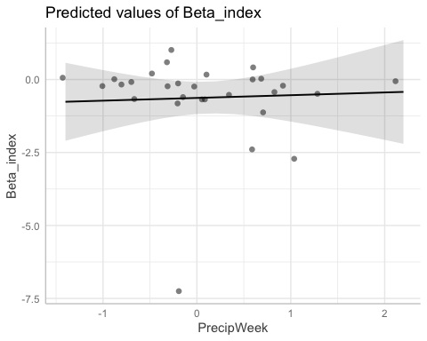

##   
## $PrecipMonth

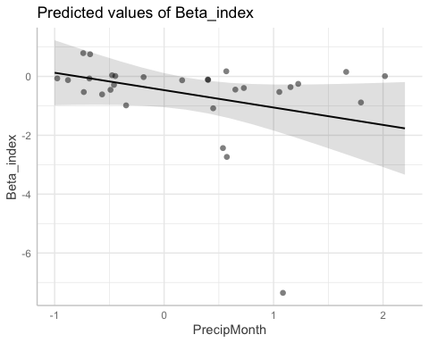

##   
## $TimeSinceChena

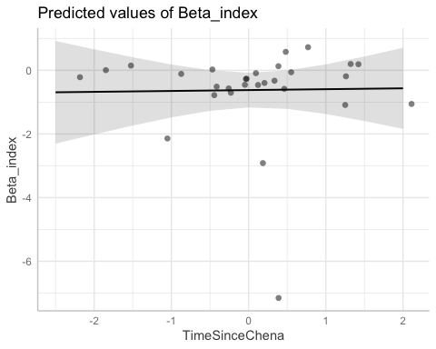

fr <- ggpredict(FRCH.model)  
plot(fr, add.data = TRUE)

## $StormPrecip

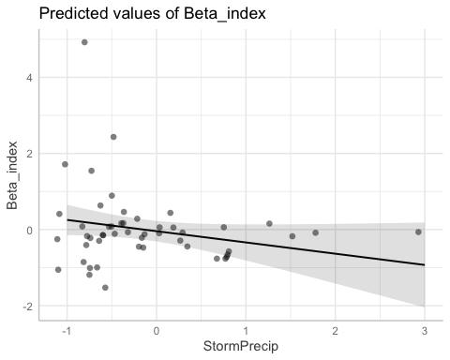

##   
## $PrecipWeek

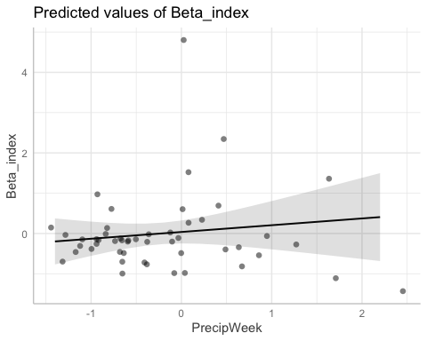

##   
## $PrecipMonth

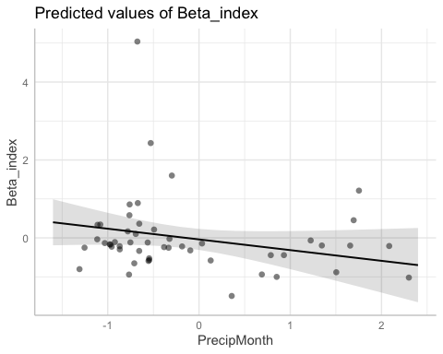

##   
## $TimeSinceChena

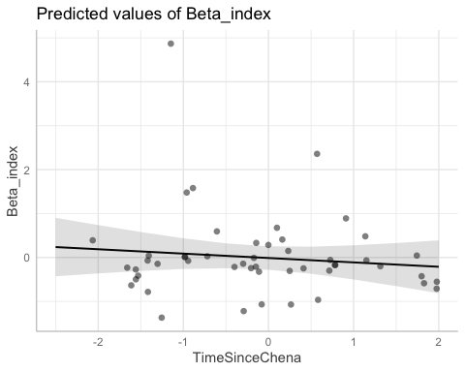

ca <- ggpredict(CARI.model)  
plot(ca, add.data = TRUE)

## $StormPrecip

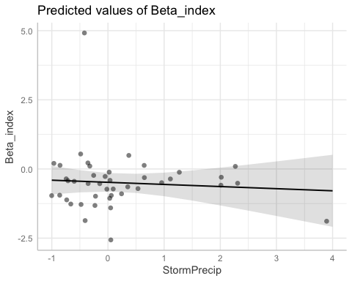

##   
## $PrecipWeek

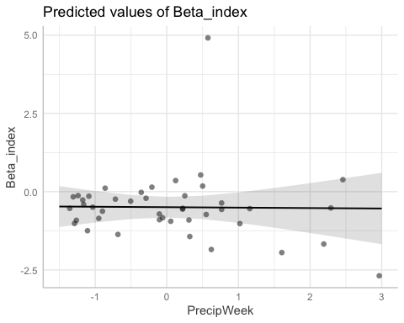

##   
## $PrecipMonth

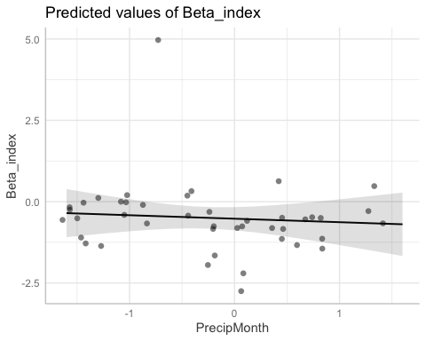

##   
## $TimeSinceChena

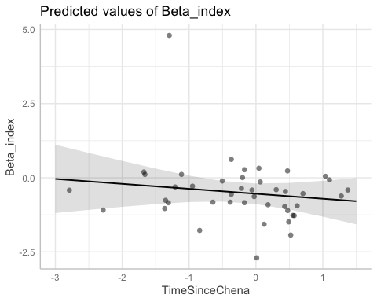

po <- ggpredict(POKE.model)  
plot(po, add.data = TRUE)

## $StormPrecip

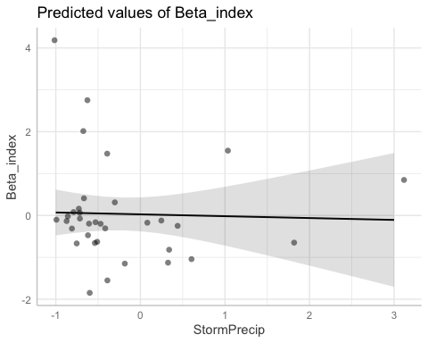

##   
## $PrecipWeek

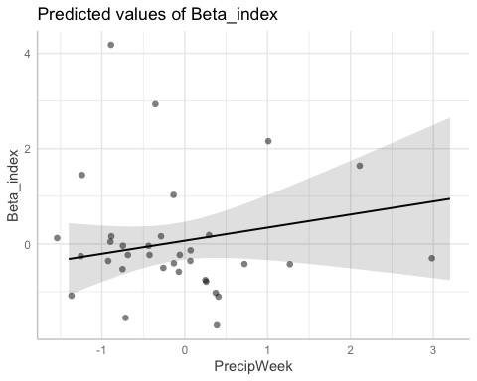

##   
## $PrecipMonth

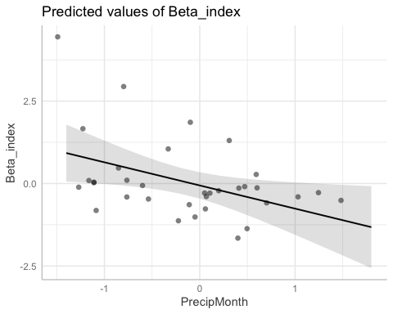

##   
## $TimeSinceChena

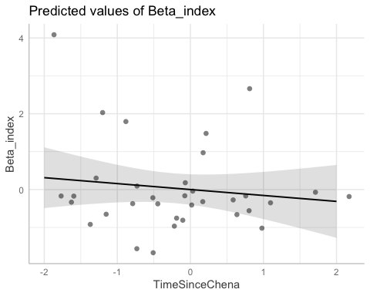

va <- ggpredict(VAUL.model)  
plot(va, add.data = TRUE)

## $StormPrecip

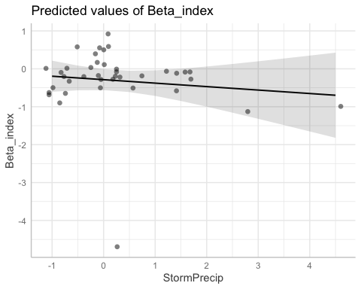

##   
## $PrecipWeek

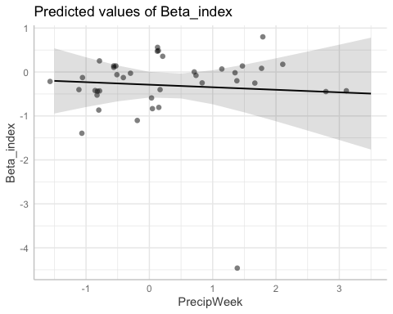

##   
## $PrecipMonth

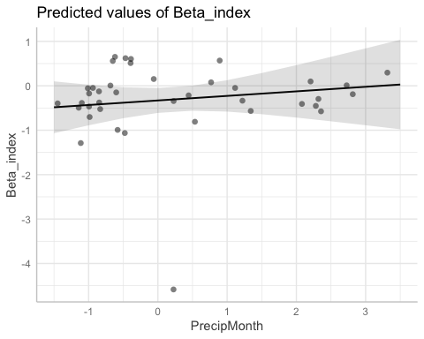

##   
## $TimeSinceChena

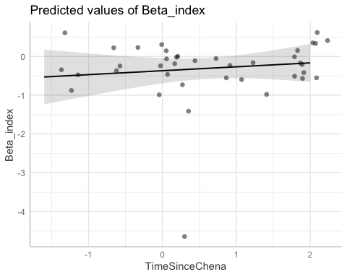

st <- ggpredict(STRT.model)  
plot(st, add.data = TRUE)

## $StormPrecip

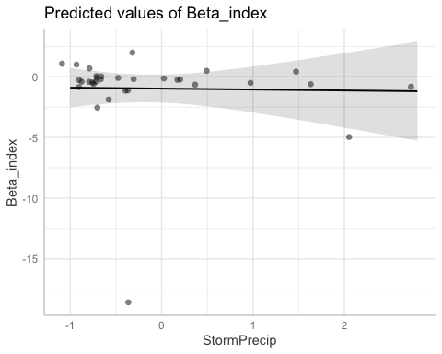

##   
## $PrecipWeek

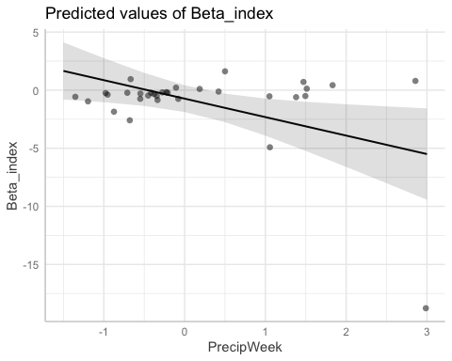

##   
## $PrecipMonth

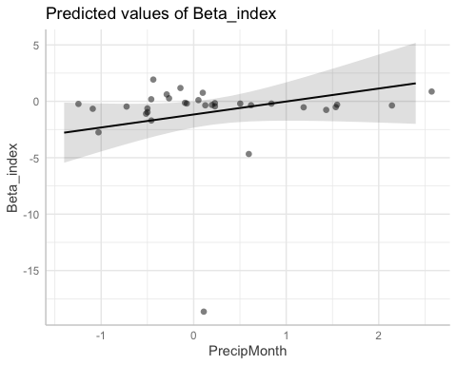

##   
## $TimeSinceChena

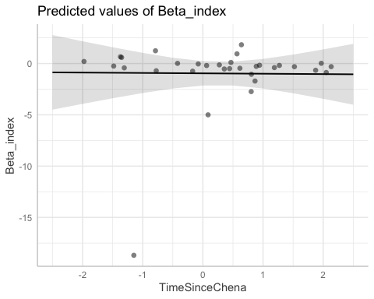

# fDOM

fDOM_data <- HI_FI_fDOM[,c("Beta_index", "site.ID", "StormPrecip", "PrecipWeek", "PrecipMonth", "ThreeMonth", "Intensity", "TimeSinceChena", "pf", "burn", "year")]  
fDOM_data <- na.omit(fDOM_data) # 244 to 236 rows   
  
fDOM_data <- fDOM_data[, c(1,3,4,5,6,7,8,2,9,10,11)]  
cor(fDOM_data[,c(1:7)])

## Beta_index StormPrecip PrecipWeek PrecipMonth ThreeMonth  
## Beta_index 1.00000000 -0.08936141 -0.135298449 -0.10580489 0.01919646  
## StormPrecip -0.08936141 1.00000000 0.073511598 -0.03618970 -0.11436014  
## PrecipWeek -0.13529845 0.07351160 1.000000000 0.58841070 0.24254745  
## PrecipMonth -0.10580489 -0.03618970 0.588410701 1.00000000 0.62108498  
## ThreeMonth 0.01919646 -0.11436014 0.242547447 0.62108498 1.00000000  
## Intensity -0.03979125 0.60176589 0.008881635 -0.01603040 -0.08019796  
## TimeSinceChena 0.02227755 -0.07090000 -0.072184065 0.09601966 0.54711873  
## Intensity TimeSinceChena  
## Beta_index -0.039791248 0.02227755  
## StormPrecip 0.601765894 -0.07090000  
## PrecipWeek 0.008881635 -0.07218407  
## PrecipMonth -0.016030396 0.09601966  
## ThreeMonth -0.080197959 0.54711873  
## Intensity 1.000000000 -0.05407492  
## TimeSinceChena -0.054074923 1.00000000

ggpairs(fDOM_data,  
 columns = 1:7,  
 ggplot2::aes(colour = site.ID))

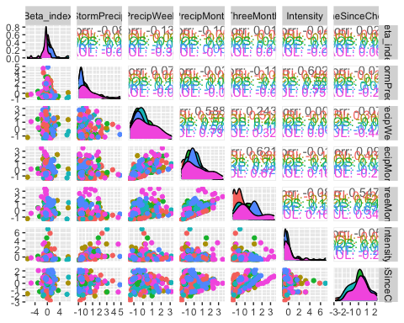

ggsave("pairs1.pdf",  
 width = 10, height = 10)

HI_FI_fDOM_MOOS <- subset(HI_FI_fDOM, site.ID == "MOOS")  
HI_FI_fDOM_FRCH <- subset(HI_FI_fDOM, site.ID == "FRCH")  
HI_FI_fDOM_CARI <- subset(HI_FI_fDOM, site.ID == "CARI")  
HI_FI_fDOM_POKE <- subset(HI_FI_fDOM, site.ID == "POKE")  
HI_FI_fDOM_VAUL <- subset(HI_FI_fDOM, site.ID == "VAUL")  
HI_FI_fDOM_STRT <- subset(HI_FI_fDOM, site.ID == "STRT")  
  
MOOS.model <- lm(Beta_index ~ StormPrecip + PrecipWeek + PrecipMonth + TimeSinceChena, data = HI_FI_fDOM_MOOS)  
  
FRCH.model <- lm(Beta_index ~ StormPrecip + PrecipWeek + PrecipMonth + TimeSinceChena, data = HI_FI_fDOM_FRCH)  
  
CARI.model <- lm(Beta_index ~ StormPrecip + PrecipWeek + PrecipMonth + TimeSinceChena, data = HI_FI_fDOM_CARI)  
  
POKE.model <- lm(Beta_index ~ StormPrecip + PrecipWeek + PrecipMonth + TimeSinceChena, data = HI_FI_fDOM_POKE)  
  
VAUL.model <- lm(Beta_index ~ StormPrecip + PrecipWeek + PrecipMonth + TimeSinceChena, data = HI_FI_fDOM_VAUL)  
  
STRT.model <- lm(Beta_index ~ StormPrecip + PrecipWeek + PrecipMonth + TimeSinceChena, data = HI_FI_fDOM_STRT)  
  
Plot_1 <- plot_summs(MOOS.model, FRCH.model,   
 CARI.model, POKE.model,   
 VAUL.model, STRT.model, scale = TRUE,  
 model.names = c("MOOS", "FRCH", "CARI", "POKE", "VAUL", "STRT"),  
 colors = c("#A6761D", "#FF7F00","#3288BD", "#6A3D9A", "#E7298A", "#66C2A5"))

## Loading required namespace: broom.mixed  
## Loading required namespace: broom.mixed  
## Loading required namespace: broom.mixed  
## Loading required namespace: broom.mixed  
## Loading required namespace: broom.mixed  
## Loading required namespace: broom.mixed

Plot_1 +   
 xlab("Coefficient estimate") + ylab("") +  
 geom_vline(xintercept = 0,  
 colour = "grey80",  
 linetype = 1) +   
scale_y_discrete(labels= c("Seasonality",   
 "Precipitation Month",   
 "Precipitation Week",  
 "Storm Precipitation")) +  
 theme_bw()

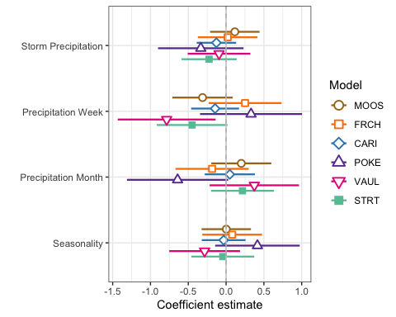

ggsave(path = "~/Documents/Storms_clean_repo/plots/Coefficient_Plots/BETA",   
 filename = "BETA_fDOM.pdf",  
 width = 7, height = 7)

M1 <- lmer(Beta_index ~ StormPrecip + PrecipWeek + PrecipMonth + TimeSinceChena + (1|site.ID), data = HI_FI_fDOM)  
pr <- ggpredict(M1)  
  
plot(pr, add.data = TRUE)

## $StormPrecip

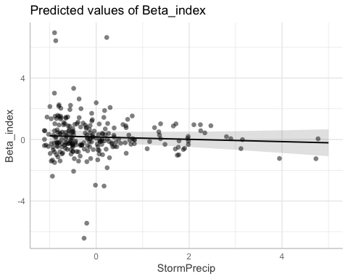

##   
## $PrecipWeek

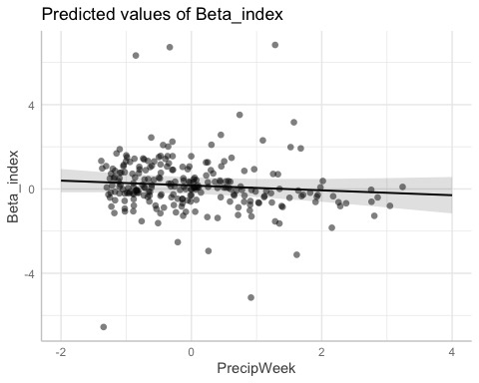

##   
## $PrecipMonth

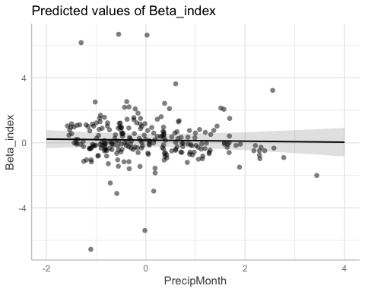

##   
## $TimeSinceChena

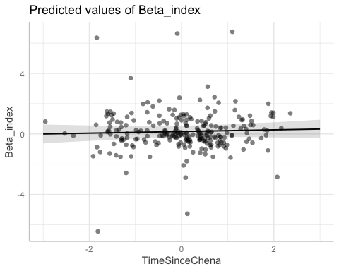

# partial residual plot test to get each site by color   
mo <- ggpredict(MOOS.model)  
plot(mo, add.data = TRUE)

## $StormPrecip

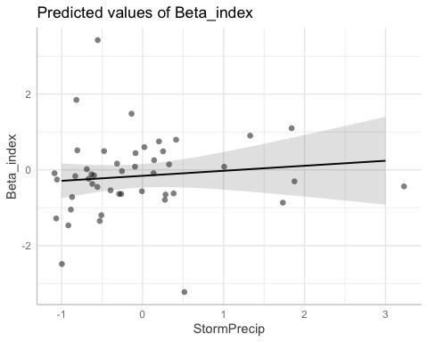

##   
## $PrecipWeek

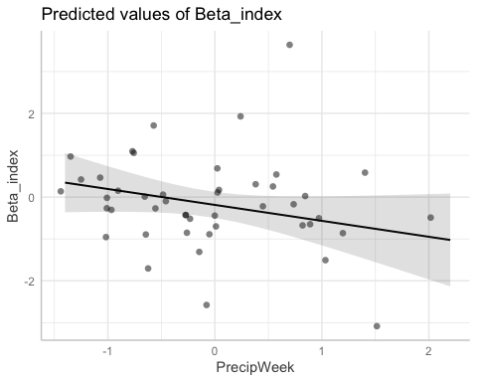

##   
## $PrecipMonth

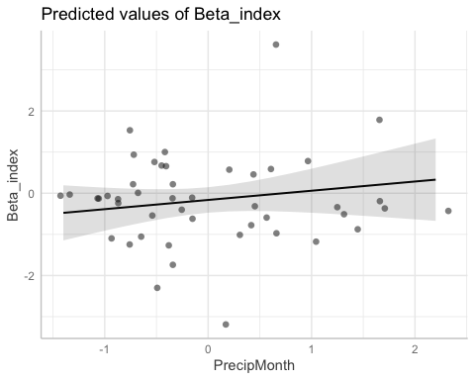

##   
## $TimeSinceChena

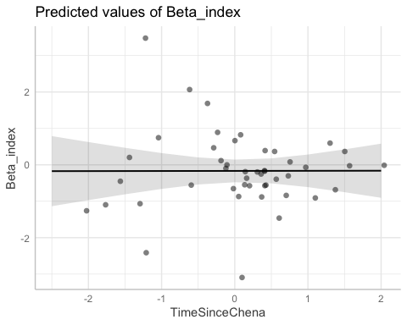

fr <- ggpredict(FRCH.model)  
plot(fr, add.data = TRUE)

## $StormPrecip

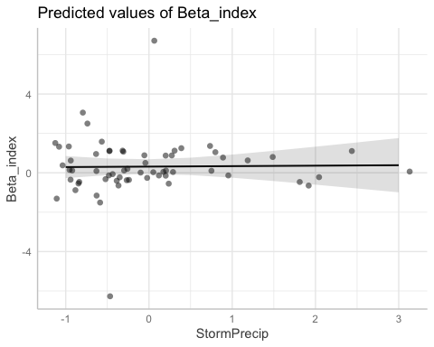

##   
## $PrecipWeek

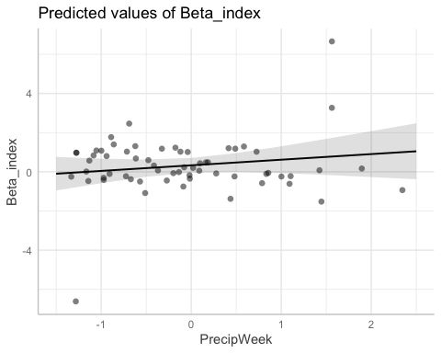

##   
## $PrecipMonth

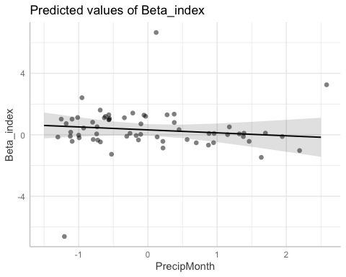

##   
## $TimeSinceChena

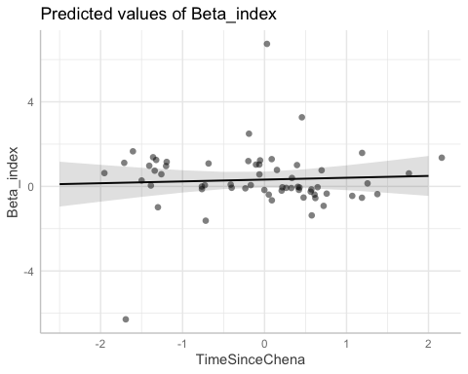

ca <- ggpredict(CARI.model)  
plot(ca, add.data = TRUE)

## $StormPrecip

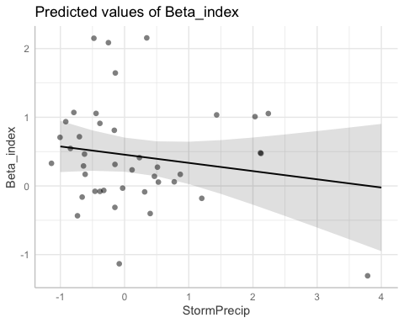

##   
## $PrecipWeek

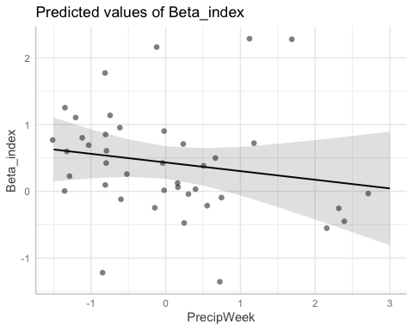

##   
## $PrecipMonth

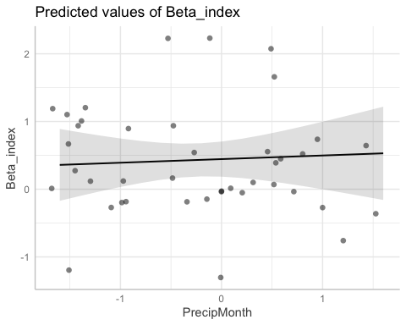

##   
## $TimeSinceChena

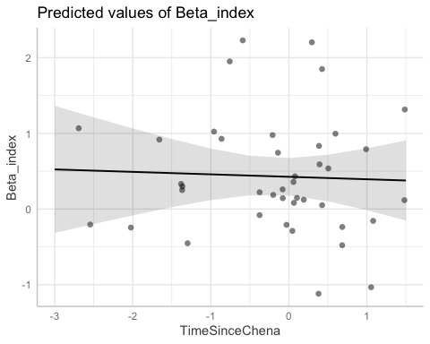

po <- ggpredict(POKE.model)  
plot(po, add.data = TRUE)

## $StormPrecip

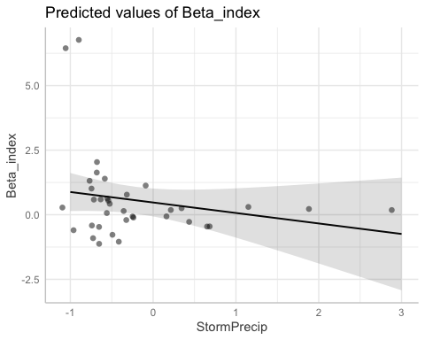

##   
## $PrecipWeek

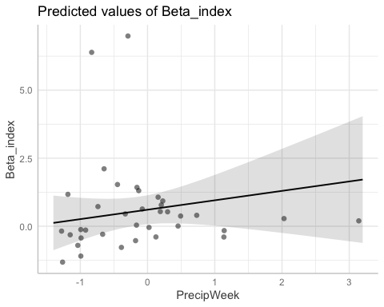

##   
## $PrecipMonth

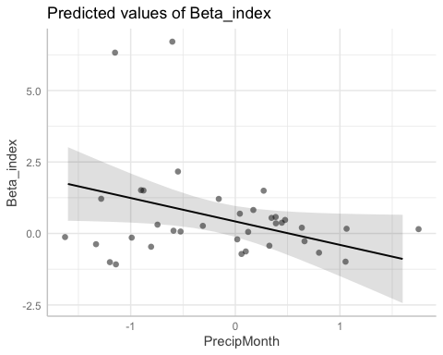

##   
## $TimeSinceChena

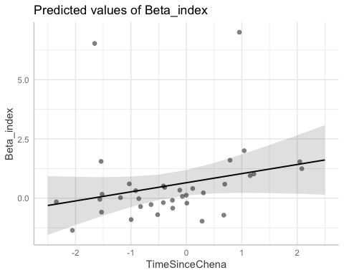

va <- ggpredict(VAUL.model)  
plot(va, add.data = TRUE)

## $StormPrecip

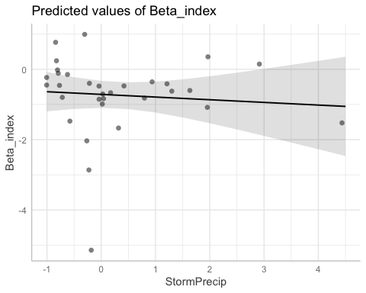

##   
## $PrecipWeek

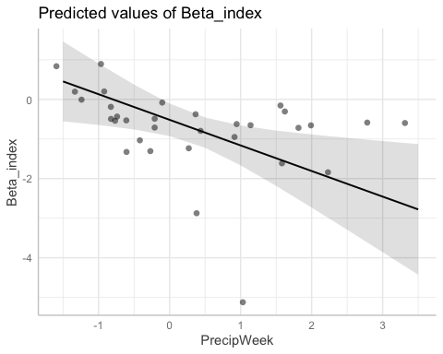

##   
## $PrecipMonth

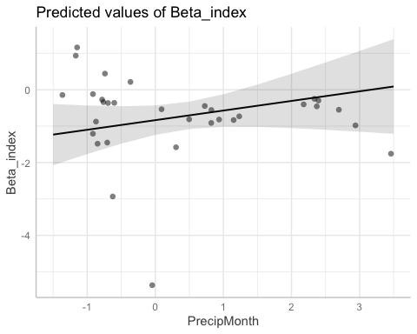

##   
## $TimeSinceChena

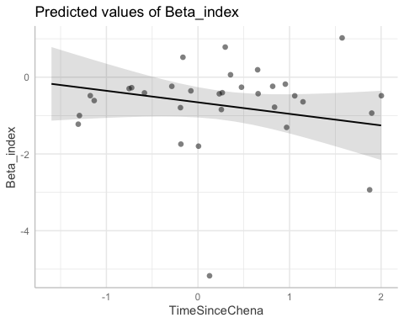

st <- ggpredict(STRT.model)  
plot(st, add.data = TRUE)

## $StormPrecip

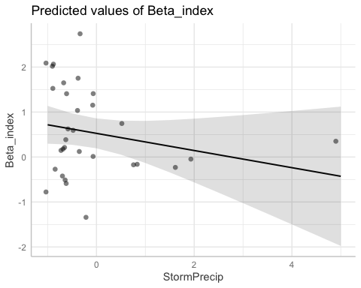

##   
## $PrecipWeek

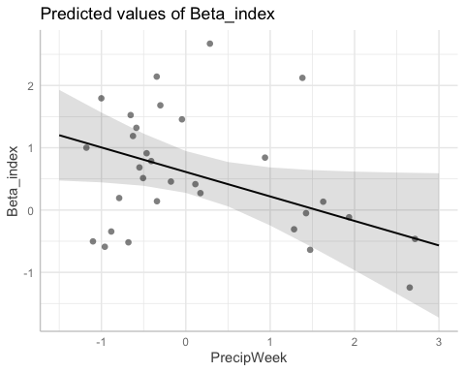

##   
## $PrecipMonth

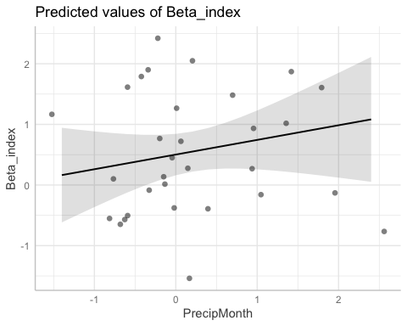

##   
## $TimeSinceChena

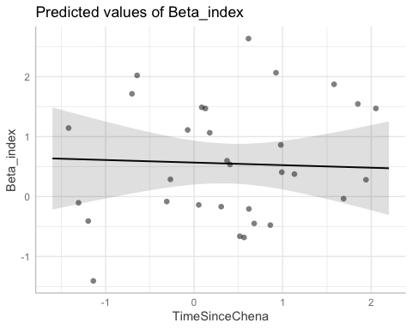

# diagnostic plots

summary(M1)

## Linear mixed model fit by REML ['lmerMod']  
## Formula:   
## Beta_index ~ StormPrecip + PrecipWeek + PrecipMonth + TimeSinceChena +   
## (1 | site.ID)  
## Data: HI_FI_fDOM  
##   
## REML criterion at convergence: 828.4  
##   
## Scaled residuals:   
## Min 1Q Median 3Q Max   
## -5.5378 -0.4374 -0.0589 0.4264 5.3379   
##   
## Random effects:  
## Groups Name Variance Std.Dev.  
## site.ID (Intercept) 0.1929 0.4392   
## Residual 1.5270 1.2357   
## Number of obs: 248, groups: site.ID, 6  
##   
## Fixed effects:  
## Estimate Std. Error t value  
## (Intercept) 0.16463 0.19655 0.838  
## StormPrecip -0.07487 0.08028 -0.933  
## PrecipWeek -0.11529 0.09940 -1.160  
## PrecipMonth -0.03152 0.10123 -0.311  
## TimeSinceChena 0.05447 0.08297 0.656  
##   
## Correlation of Fixed Effects:  
## (Intr) StrmPr PrcpWk PrcpMn  
## StormPrecip -0.003   
## PrecipWeek -0.013 -0.099   
## PrecipMonth 0.000 0.087 -0.603   
## TimeSincChn -0.016 0.057 0.155 -0.154

plot(M1, type=c("p","smooth"), col.line=1)

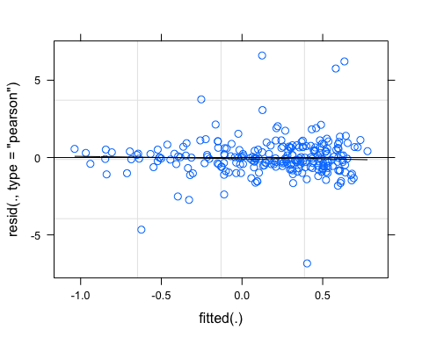

lattice::qqmath(M1)

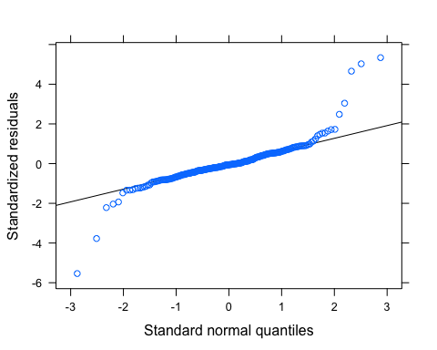

plot(M1, rstudent(.) ~ hatvalues(.))

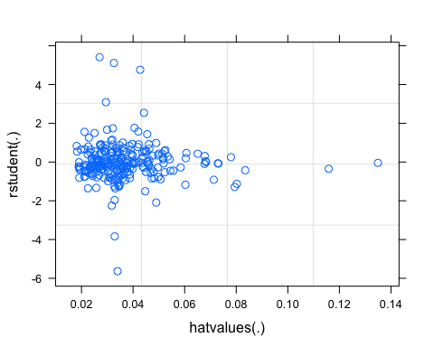

# SPC

SPC_data <- HI_FI_SPC[,c("Beta_index", "site.ID", "StormPrecip", "PrecipWeek", "PrecipMonth", "ThreeMonth", "Intensity", "TimeSinceChena", "pf", "burn", "year")]  
SPC_data <- na.omit(SPC_data) # 244 to 236 rows   
  
SPC_data <- SPC_data[, c(1,3,4,5,6,7,8,2,9,10,11)]  
cor(SPC_data[,c(1:7)])

## Beta_index StormPrecip PrecipWeek PrecipMonth ThreeMonth  
## Beta_index 1.000000000 0.03484039 -0.15344377 -0.05203947 0.001883198  
## StormPrecip 0.034840392 1.00000000 0.05943248 -0.05170012 -0.104099523  
## PrecipWeek -0.153443774 0.05943248 1.00000000 0.59603265 0.253607284  
## PrecipMonth -0.052039466 -0.05170012 0.59603265 1.00000000 0.641169370  
## ThreeMonth 0.001883198 -0.10409952 0.25360728 0.64116937 1.000000000  
## Intensity 0.038608082 0.61625146 -0.00546886 -0.05212273 -0.090941665  
## TimeSinceChena 0.063680734 -0.06514122 -0.07718973 0.11930084 0.541821707  
## Intensity TimeSinceChena  
## Beta_index 0.03860808 0.06368073  
## StormPrecip 0.61625146 -0.06514122  
## PrecipWeek -0.00546886 -0.07718973  
## PrecipMonth -0.05212273 0.11930084  
## ThreeMonth -0.09094166 0.54182171  
## Intensity 1.00000000 -0.05719742  
## TimeSinceChena -0.05719742 1.00000000

ggpairs(SPC_data,  
 columns = 1:7,  
 ggplot2::aes(colour = site.ID))

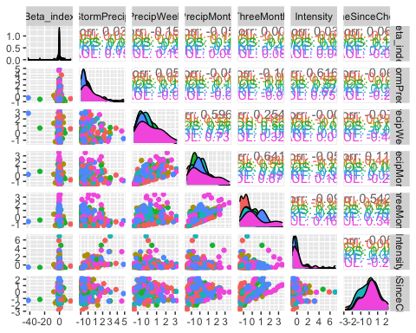

ggsave("pairs1.pdf",  
 width = 10, height = 10)

HI_FI_SPC_MOOS <- subset(HI_FI_SPC, site.ID == "MOOS")  
HI_FI_SPC_FRCH <- subset(HI_FI_SPC, site.ID == "FRCH")  
HI_FI_SPC_CARI <- subset(HI_FI_SPC, site.ID == "CARI")  
HI_FI_SPC_POKE <- subset(HI_FI_SPC, site.ID == "POKE")  
HI_FI_SPC_VAUL <- subset(HI_FI_SPC, site.ID == "VAUL")  
HI_FI_SPC_STRT <- subset(HI_FI_SPC, site.ID == "STRT")  
  
MOOS.model <- lm(Beta_index ~ StormPrecip + PrecipWeek + PrecipMonth + TimeSinceChena, data = HI_FI_SPC_MOOS)  
  
FRCH.model <- lm(Beta_index ~ StormPrecip + PrecipWeek + PrecipMonth + TimeSinceChena, data = HI_FI_SPC_FRCH)  
  
CARI.model <- lm(Beta_index ~ StormPrecip + PrecipWeek + PrecipMonth + TimeSinceChena, data = HI_FI_SPC_CARI)  
  
POKE.model <- lm(Beta_index ~ StormPrecip + PrecipWeek + PrecipMonth + TimeSinceChena, data = HI_FI_SPC_POKE)  
  
VAUL.model <- lm(Beta_index ~ StormPrecip + PrecipWeek + PrecipMonth + TimeSinceChena, data = HI_FI_SPC_VAUL)  
  
STRT.model <- lm(Beta_index ~ StormPrecip + PrecipWeek + PrecipMonth + TimeSinceChena, data = HI_FI_SPC_STRT)  
  
Plot_1 <- plot_summs(MOOS.model, FRCH.model,   
 CARI.model, POKE.model,   
 VAUL.model, STRT.model, scale = TRUE,  
 model.names = c("MOOS", "FRCH", "CARI", "POKE", "VAUL", "STRT"),  
 colors = c("#A6761D", "#FF7F00","#3288BD", "#6A3D9A", "#E7298A", "#66C2A5"))

## Loading required namespace: broom.mixed  
## Loading required namespace: broom.mixed  
## Loading required namespace: broom.mixed  
## Loading required namespace: broom.mixed  
## Loading required namespace: broom.mixed  
## Loading required namespace: broom.mixed

Plot_1 +   
 xlab("Coefficient estimate") + ylab("") +  
 geom_vline(xintercept = 0,  
 colour = "grey80",  
 linetype = 1) +   
scale_y_discrete(labels= c("Seasonality",   
 "Precipitation Month",   
 "Precipitation Week",  
 "Storm Precipitation")) +  
 theme_bw()

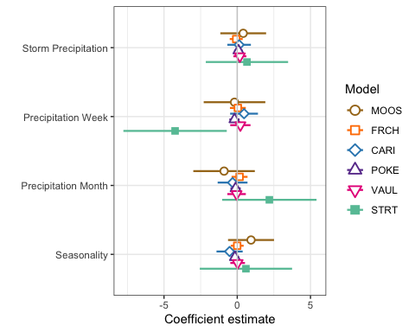

ggsave(path = "~/Documents/Storms_clean_repo/plots/Coefficient_Plots/BETA",   
 filename = "BETA_SPC.pdf",  
 width = 7, height = 7)

M1 <- lmer(Beta_index ~ StormPrecip + PrecipWeek + PrecipMonth + TimeSinceChena + (1|site.ID), data = HI_FI_SPC)

## boundary (singular) fit: see ?isSingular

pr <- ggpredict(M1)  
  
plot(pr, add.data = TRUE)

## $StormPrecip

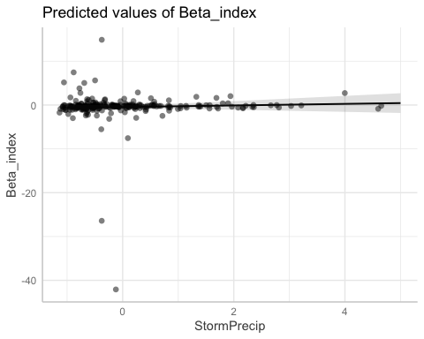

##   
## $PrecipWeek

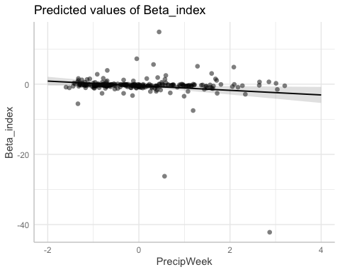

##   
## $PrecipMonth

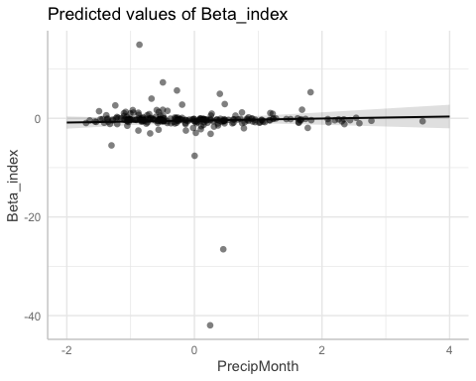

##   
## $TimeSinceChena

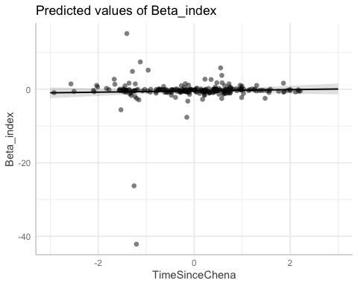

# partial residual plot test to get each site by color   
mo <- ggpredict(MOOS.model)  
plot(mo, add.data = TRUE)

## $StormPrecip

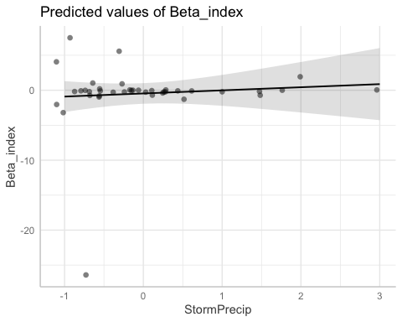

##   
## $PrecipWeek

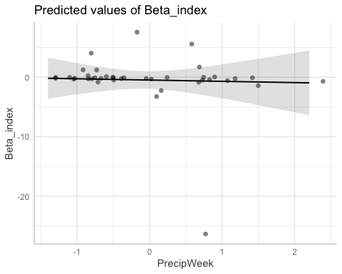

##   
## $PrecipMonth

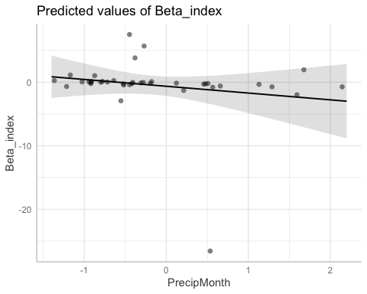

##   
## $TimeSinceChena

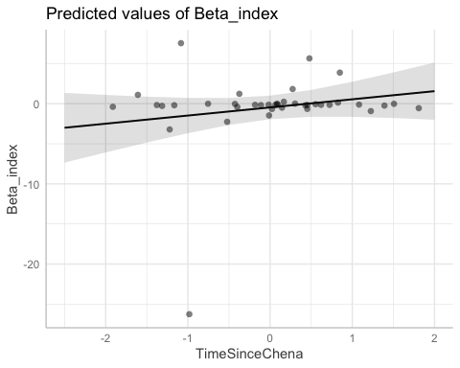

fr <- ggpredict(FRCH.model)  
plot(fr, add.data = TRUE)

## $StormPrecip

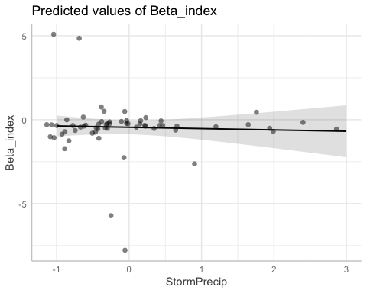

##   
## $PrecipWeek

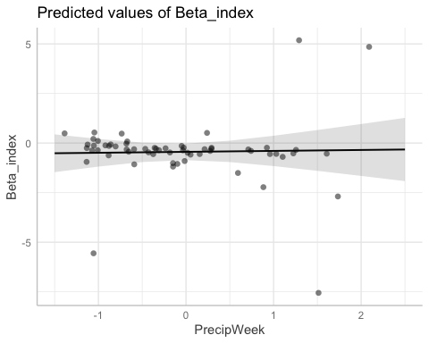

##   
## $PrecipMonth

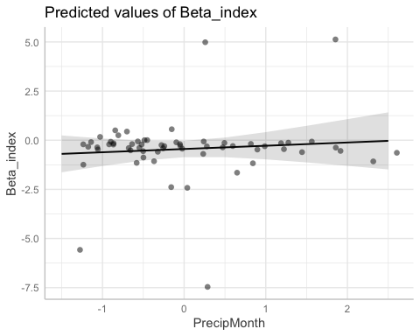

##   
## $TimeSinceChena

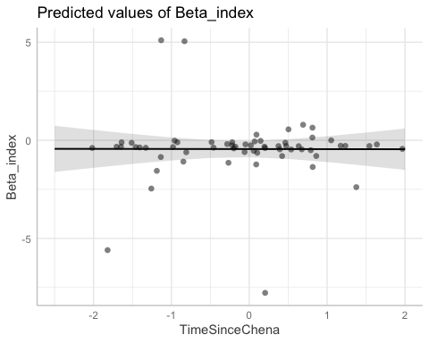

ca <- ggpredict(CARI.model)  
plot(ca, add.data = TRUE)

## $StormPrecip

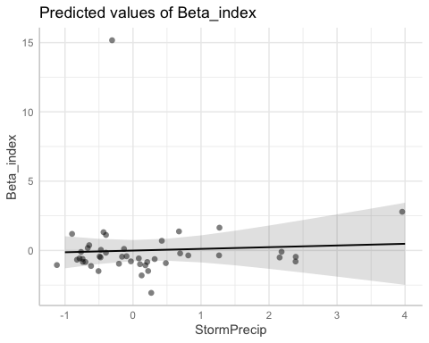

##   
## $PrecipWeek

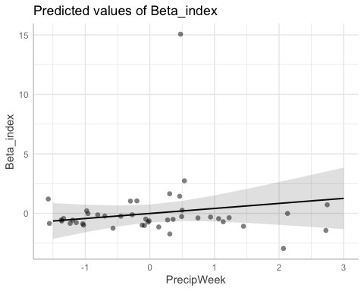

##   
## $PrecipMonth

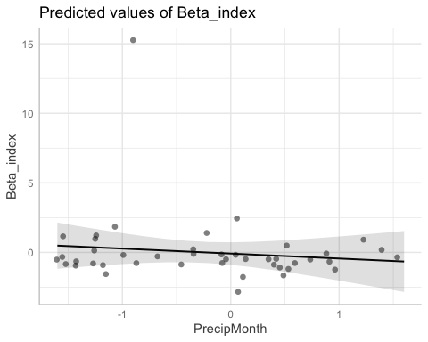

##   
## $TimeSinceChena

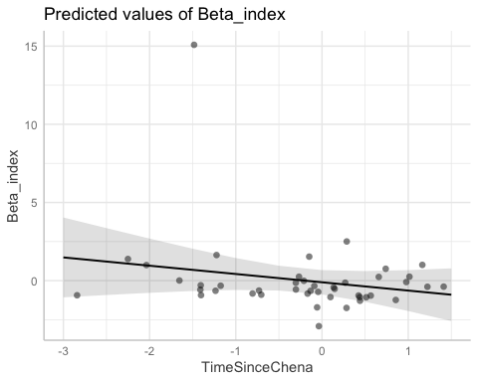

po <- ggpredict(POKE.model)  
plot(po, add.data = TRUE)

## $StormPrecip

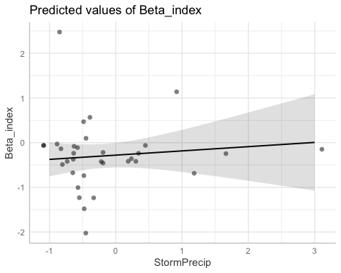

##   
## $PrecipWeek

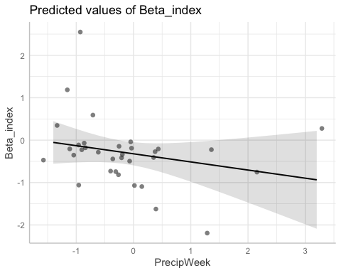

##   
## $PrecipMonth

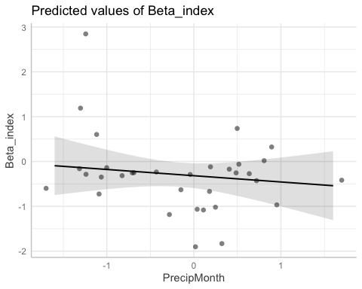

##   
## $TimeSinceChena

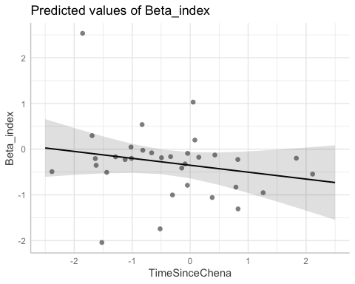

va <- ggpredict(VAUL.model)  
plot(va, add.data = TRUE)

## $StormPrecip

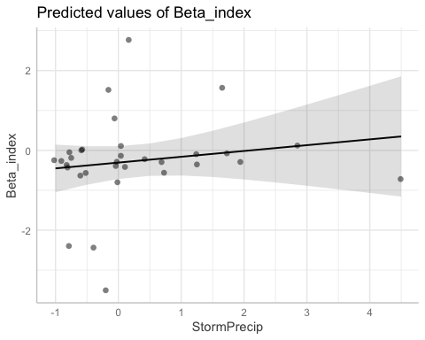

##   
## $PrecipWeek

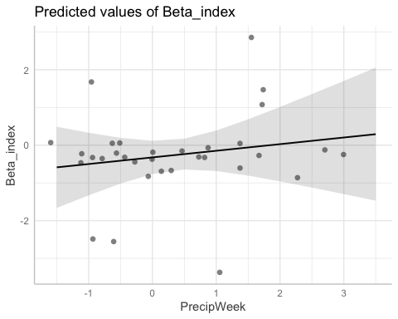

##   
## $PrecipMonth

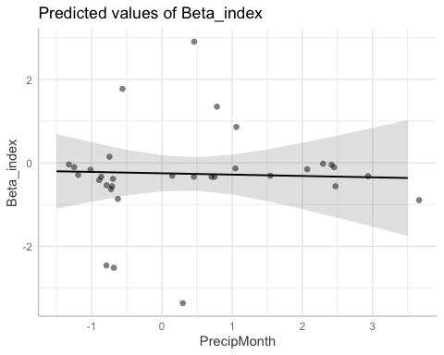

##   
## $TimeSinceChena

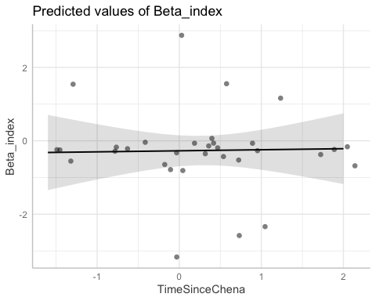

st <- ggpredict(STRT.model)  
plot(st, add.data = TRUE)

## $StormPrecip

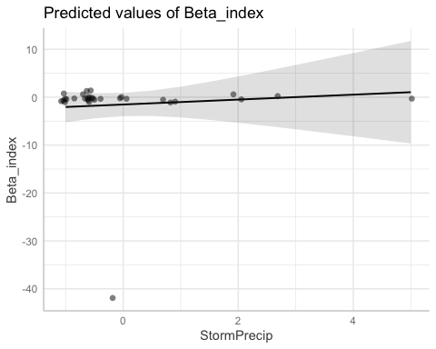

##   
## $PrecipWeek

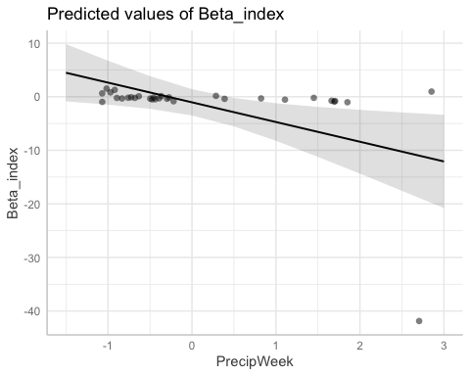

##   
## $PrecipMonth

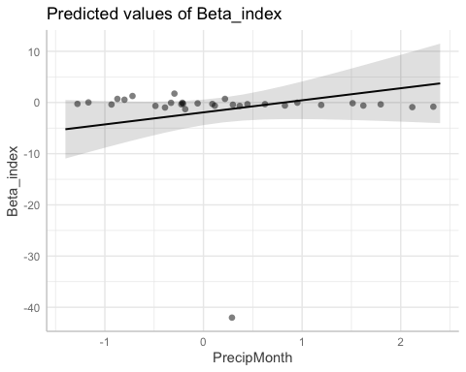

##   
## $TimeSinceChena

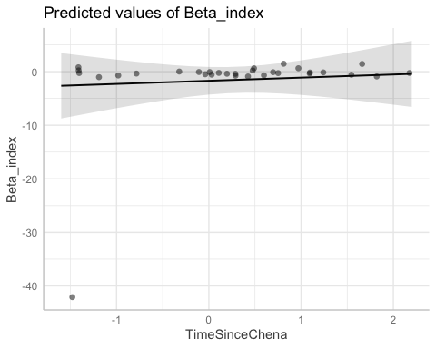

# diagnostic plots

summary(M1)

## Linear mixed model fit by REML ['lmerMod']  
## Formula:   
## Beta_index ~ StormPrecip + PrecipWeek + PrecipMonth + TimeSinceChena +   
## (1 | site.ID)  
## Data: HI_FI_SPC  
##   
## REML criterion at convergence: 1289.9  
##   
## Scaled residuals:   
## Min 1Q Median 3Q Max   
## -11.1252 -0.1104 -0.0100 0.1688 4.6058   
##   
## Random effects:  
## Groups Name Variance Std.Dev.  
## site.ID (Intercept) 0.00 0.000   
## Residual 12.63 3.554   
## Number of obs: 240, groups: site.ID, 6  
##   
## Fixed effects:  
## Estimate Std. Error t value  
## (Intercept) -0.4363 0.2299 -1.897  
## StormPrecip 0.1807 0.2266 0.797  
## PrecipWeek -0.6564 0.2875 -2.283  
## PrecipMonth 0.2031 0.2979 0.682  
## TimeSinceChena 0.1722 0.2390 0.721  
##   
## Correlation of Fixed Effects:  
## (Intr) StrmPr PrcpWk PrcpMn  
## StormPrecip -0.022   
## PrecipWeek -0.038 -0.105   
## PrecipMonth 0.034 0.097 -0.619   
## TimeSincChn 0.033 0.039 0.174 -0.205  
## optimizer (nloptwrap) convergence code: 0 (OK)  
## boundary (singular) fit: see ?isSingular

plot(M1, type=c("p","smooth"), col.line=1)

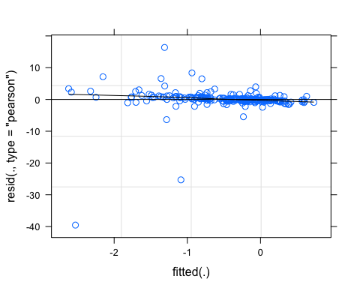

lattice::qqmath(M1)

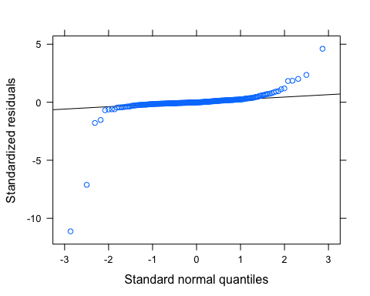

plot(M1, rstudent(.) ~ hatvalues(.))

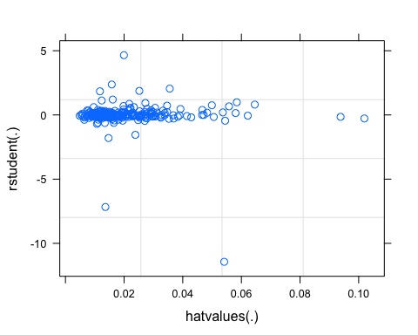 qq norm plot has some crazy tails

# turb

turb_data <- HI_FI_turb[,c("Beta_index", "site.ID", "StormPrecip", "PrecipWeek", "PrecipMonth", "ThreeMonth", "Intensity", "TimeSinceChena", "pf", "burn", "year")]  
turb_data <- na.omit(turb_data) # 244 to 236 rows   
  
turb_data <- turb_data[, c(1,3,4,5,6,7,8,2,9,10,11)]  
cor(turb_data[,c(1:7)])

## Beta_index StormPrecip PrecipWeek PrecipMonth ThreeMonth  
## Beta_index 1.000000000 0.01681267 0.129236642 0.05409206 0.006596539  
## StormPrecip 0.016812668 1.00000000 0.064319696 -0.04888347 -0.119539660  
## PrecipWeek 0.129236642 0.06431970 1.000000000 0.58288655 0.235462123  
## PrecipMonth 0.054092065 -0.04888347 0.582886551 1.00000000 0.627951514  
## ThreeMonth 0.006596539 -0.11953966 0.235462123 0.62795151 1.000000000  
## Intensity 0.013792936 0.61527201 0.005494757 -0.02844177 -0.086895709  
## TimeSinceChena -0.045242627 -0.07568906 -0.088608126 0.10847016 0.549036088  
## Intensity TimeSinceChena  
## Beta_index 0.013792936 -0.04524263  
## StormPrecip 0.615272011 -0.07568906  
## PrecipWeek 0.005494757 -0.08860813  
## PrecipMonth -0.028441775 0.10847016  
## ThreeMonth -0.086895709 0.54903609  
## Intensity 1.000000000 -0.05670096  
## TimeSinceChena -0.056700961 1.00000000

ggpairs(turb_data,  
 columns = 1:7,  
 ggplot2::aes(colour = site.ID))

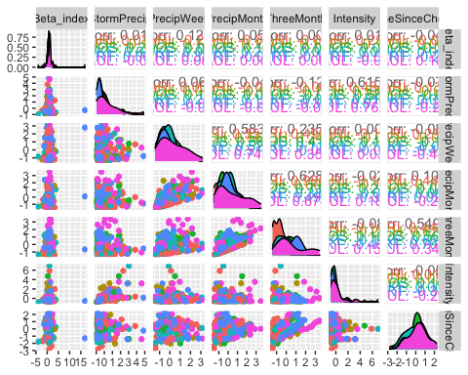

ggsave("pairs1.pdf",  
 width = 10, height = 10)

HI_FI_turb_MOOS <- subset(HI_FI_turb, site.ID == "MOOS")  
HI_FI_turb_FRCH <- subset(HI_FI_turb, site.ID == "FRCH")  
HI_FI_turb_CARI <- subset(HI_FI_turb, site.ID == "CARI")  
HI_FI_turb_POKE <- subset(HI_FI_turb, site.ID == "POKE")  
HI_FI_turb_VAUL <- subset(HI_FI_turb, site.ID == "VAUL")  
HI_FI_turb_STRT <- subset(HI_FI_turb, site.ID == "STRT")  
  
MOOS.model <- lm(Beta_index ~ StormPrecip + PrecipWeek + PrecipMonth + TimeSinceChena, data = HI_FI_turb_MOOS)  
  
FRCH.model <- lm(Beta_index ~ StormPrecip + PrecipWeek + PrecipMonth + TimeSinceChena, data = HI_FI_turb_FRCH)  
  
CARI.model <- lm(Beta_index ~ StormPrecip + PrecipWeek + PrecipMonth + TimeSinceChena, data = HI_FI_turb_CARI)  
  
POKE.model <- lm(Beta_index ~ StormPrecip + PrecipWeek + PrecipMonth + TimeSinceChena, data = HI_FI_turb_POKE)  
  
VAUL.model <- lm(Beta_index ~ StormPrecip + PrecipWeek + PrecipMonth + TimeSinceChena, data = HI_FI_turb_VAUL)  
  
STRT.model <- lm(Beta_index ~ StormPrecip + PrecipWeek + PrecipMonth + TimeSinceChena, data = HI_FI_turb_STRT)  
  
Plot_1 <- plot_summs(MOOS.model, FRCH.model,   
 CARI.model, POKE.model,   
 VAUL.model, STRT.model, scale = TRUE,  
 model.names = c("MOOS", "FRCH", "CARI", "POKE", "VAUL", "STRT"),  
 colors = c("#A6761D", "#FF7F00","#3288BD", "#6A3D9A", "#E7298A", "#66C2A5"))

## Loading required namespace: broom.mixed  
## Loading required namespace: broom.mixed  
## Loading required namespace: broom.mixed  
## Loading required namespace: broom.mixed  
## Loading required namespace: broom.mixed  
## Loading required namespace: broom.mixed

Plot_1 +   
 xlab("Coefficient estimate") + ylab("") +  
 geom_vline(xintercept = 0,  
 colour = "grey80",  
 linetype = 1) +   
scale_y_discrete(labels= c("Seasonality",   
 "Precipitation Month",   
 "Precipitation Week",  
 "Storm Precipitation")) +  
 theme_bw()

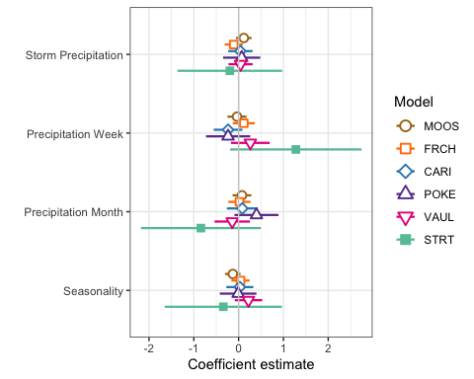

ggsave(path = "~/Documents/Storms_clean_repo/plots/Coefficient_Plots/BETA",   
 filename = "BETA_turb.pdf",  
 width = 7, height = 7)

M1 <- lmer(Beta_index ~ StormPrecip + PrecipWeek + PrecipMonth + TimeSinceChena + (1|site.ID), data = HI_FI_turb)  
pr <- ggpredict(M1)  
  
plot(pr, add.data = TRUE)

## $StormPrecip

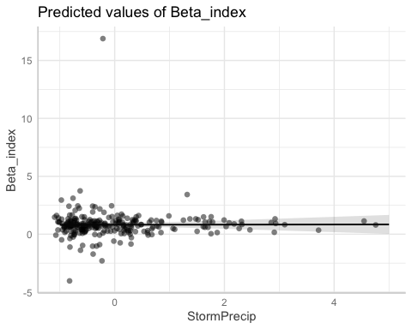

##   
## $PrecipWeek

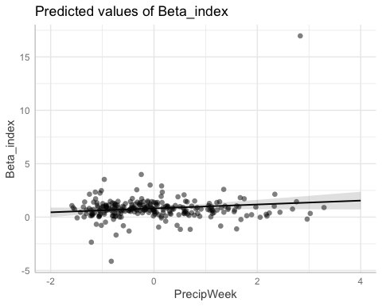

##   
## $PrecipMonth

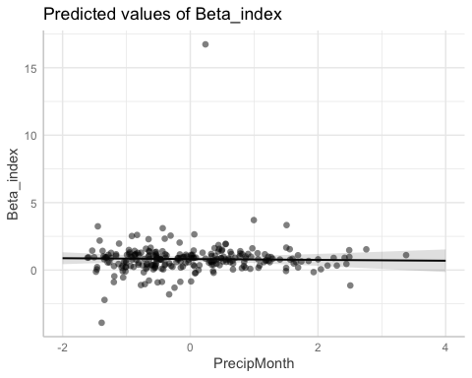

##   
## $TimeSinceChena

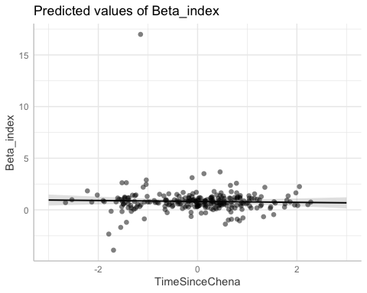

# partial residual plot test to get each site by color   
mo <- ggpredict(MOOS.model)  
plot(mo, add.data = TRUE)

## $StormPrecip

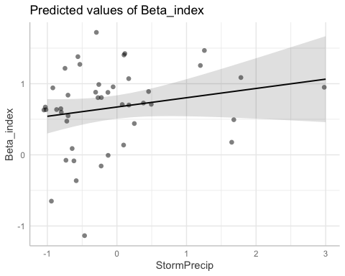

##   
## $PrecipWeek

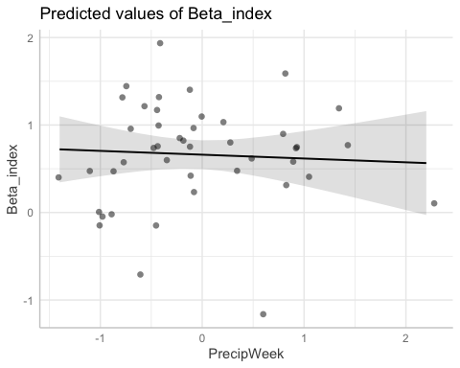

##   
## $PrecipMonth

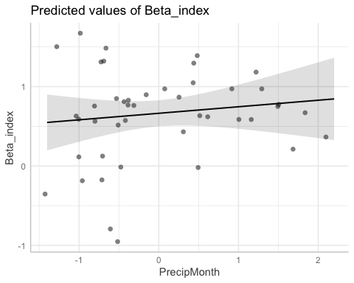

##   
## $TimeSinceChena

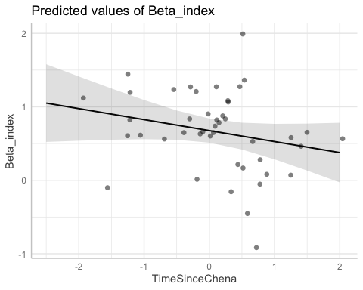

fr <- ggpredict(FRCH.model)  
plot(fr, add.data = TRUE)

## $StormPrecip

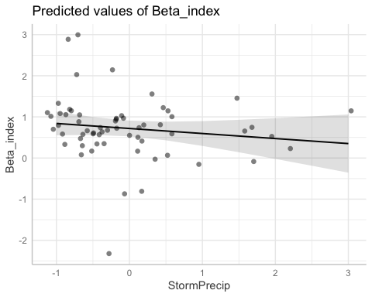

##   
## $PrecipWeek

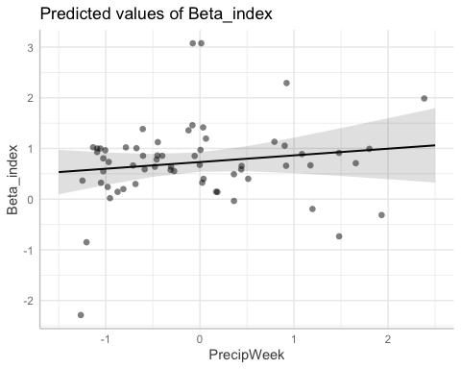

##   
## $PrecipMonth

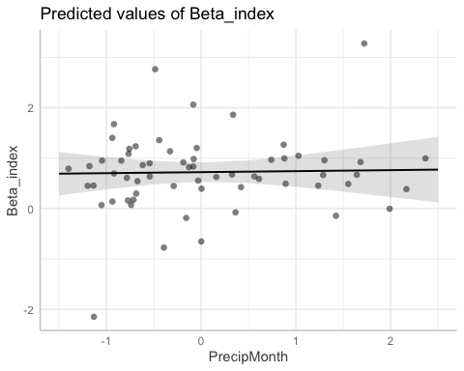

##   
## $TimeSinceChena

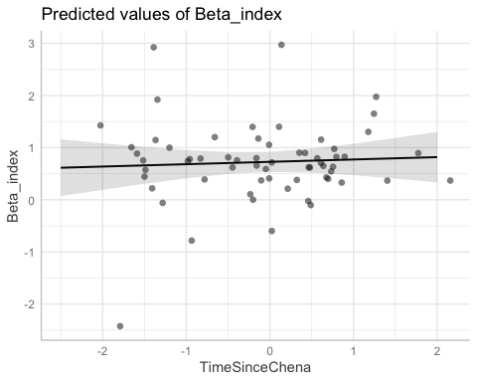

ca <- ggpredict(CARI.model)  
plot(ca, add.data = TRUE)

## $StormPrecip

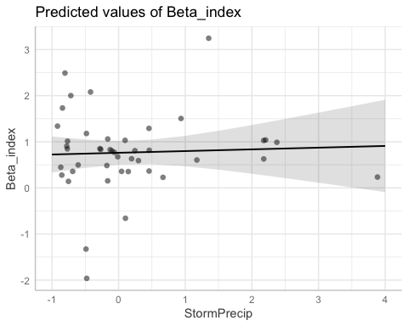

##   
## $PrecipWeek

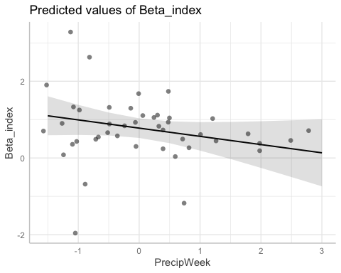

##   
## $PrecipMonth

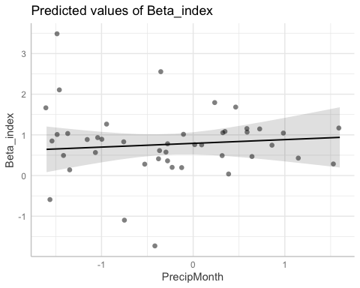

##   
## $TimeSinceChena

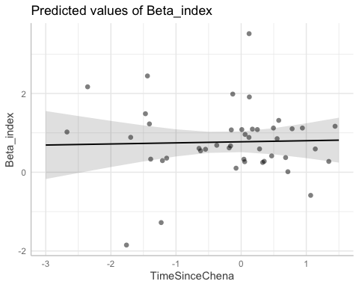

po <- ggpredict(POKE.model)  
plot(po, add.data = TRUE)

## $StormPrecip

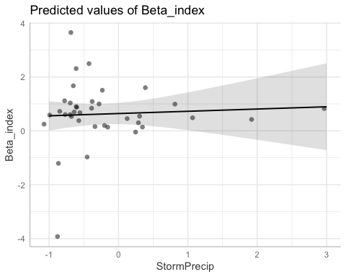

##   
## $PrecipWeek

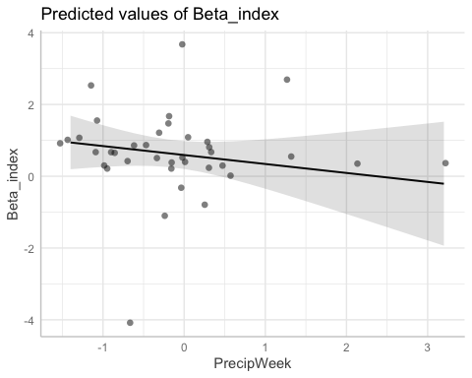

##   
## $PrecipMonth

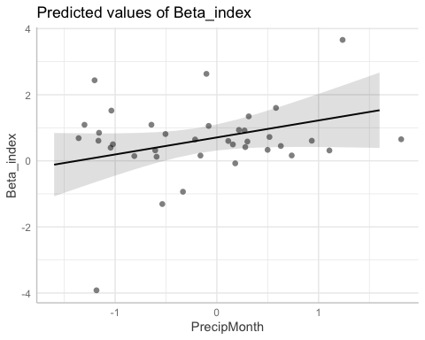

##   
## $TimeSinceChena

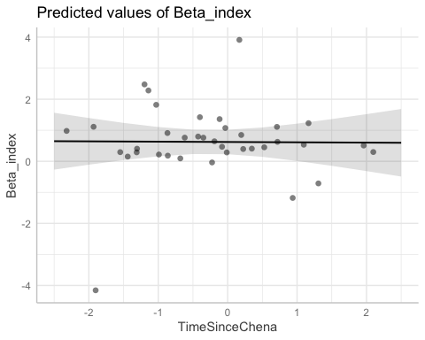

va <- ggpredict(VAUL.model)  
plot(va, add.data = TRUE)

## $StormPrecip

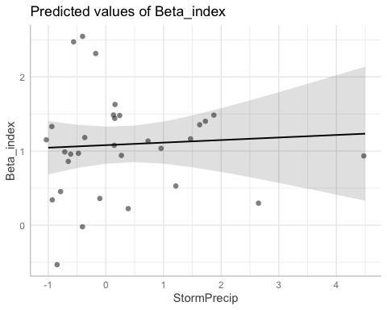

##   
## $PrecipWeek

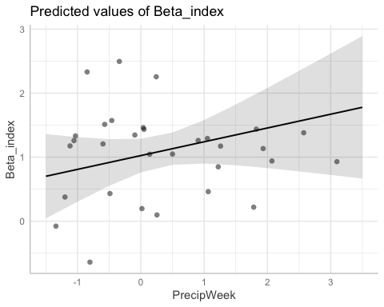

##   
## $PrecipMonth

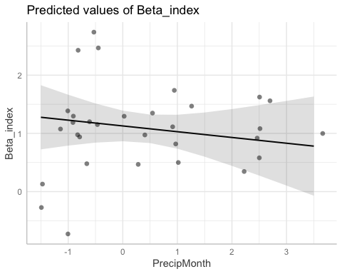

##   
## $TimeSinceChena

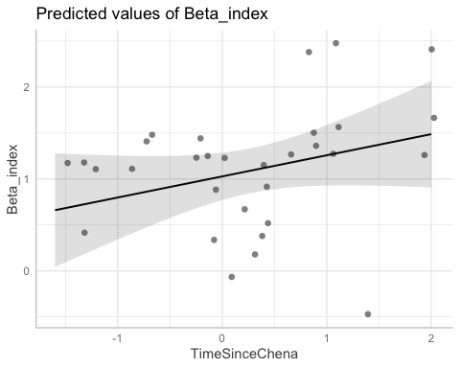

st <- ggpredict(STRT.model)  
plot(st, add.data = TRUE)

## $StormPrecip

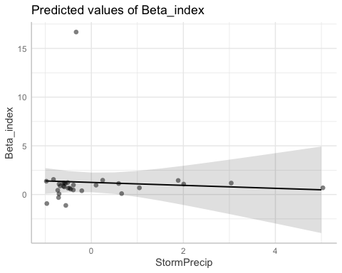

##   
## $PrecipWeek

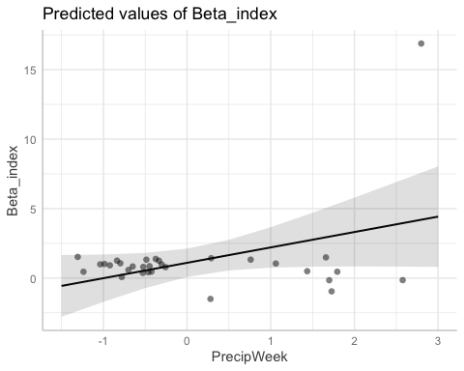

##   
## $PrecipMonth

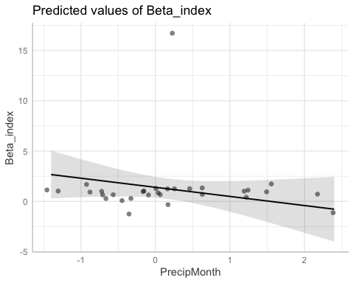

##   
## $TimeSinceChena

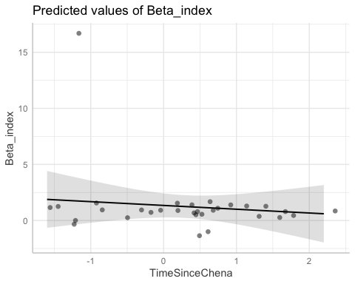

# diagnostic plots

summary(M1)

## Linear mixed model fit by REML ['lmerMod']  
## Formula:   
## Beta_index ~ StormPrecip + PrecipWeek + PrecipMonth + TimeSinceChena +   
## (1 | site.ID)  
## Data: HI_FI_turb  
##   
## REML criterion at convergence: 846.4  
##   
## Scaled residuals:   
## Min 1Q Median 3Q Max   
## -3.6976 -0.3475 -0.0106 0.2629 11.9167   
##   
## Random effects:  
## Groups Name Variance Std.Dev.  
## site.ID (Intercept) 0.0018 0.04243   
## Residual 1.6807 1.29641   
## Number of obs: 249, groups: site.ID, 6  
##   
## Fixed effects:  
## Estimate Std. Error t value  
## (Intercept) 0.814002 0.084099 9.679  
## StormPrecip 0.005659 0.082102 0.069  
## PrecipWeek 0.182549 0.104094 1.754  
## PrecipMonth -0.031116 0.104968 -0.296  
## TimeSinceChena -0.044683 0.086413 -0.517  
##   
## Correlation of Fixed Effects:  
## (Intr) StrmPr PrcpWk PrcpMn  
## StormPrecip -0.010   
## PrecipWeek -0.014 -0.105   
## PrecipMonth 0.002 0.093 -0.607   
## TimeSincChn 0.012 0.050 0.175 -0.195

plot(M1, type=c("p","smooth"), col.line=1)

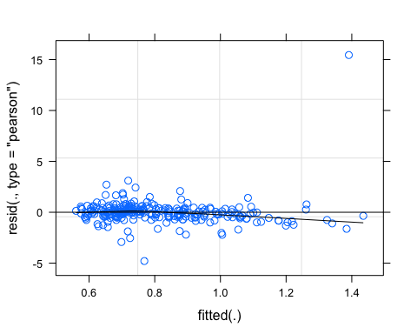

lattice::qqmath(M1)

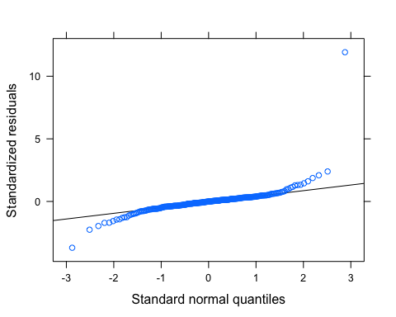

plot(M1, rstudent(.) ~ hatvalues(.))

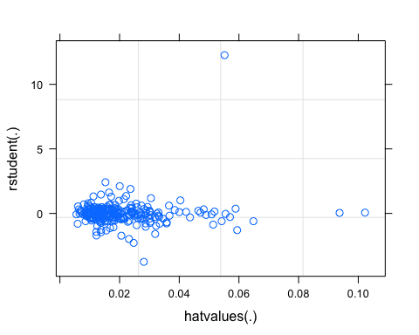 residuals are normally distributed and qqnorm plot got some big tails